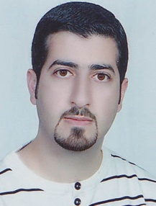
Personal and Contact Info
Name and Surname: Mahmoud Reazi
Resident of: Kerman, Iran
Cell No.: +98 912 49864781
Primary Email: sm_reazi@yahoo.com
Proz Link: www.proz.com/profile/996892

Educational Background:
- MA in Translation Studies, University of Kerman, 2008 – 2011
- BA in English Translation, University of Kerman, 2004 – 2008

Professional Experience
- Official Translator, Abbas Nejad Official Translation Office, Kerman, 2009 to present;
- Lecturer, University of Kerman, fall 2014-2015 to present (teaching translation courses);
- Editor of English Papers, International Journal of Health Policy and Management, 2013 – 2014
- Interpreter, Roshd International Film Festival, Tehran, 2009
- Interpreter, 2nd International Symposium of Veterinary Surgery, Kerman, 2008
- Professional Persian <> English translator/editor since 2004

Publications
- Universals of Translation: A Case Study of Persian to English Translation, MA Thesis, 2011;
- Universals of Translation: A Case Study of Persian to English Translation, a paper on IJLI, 2014
- Translation of ‘Walk Two Moons’, a novel by Sharon Creech, Tirgan Pub. Tehran, 2005
- Translation of ‘Ministry of Education and Sports of Israel’, Abed Pub. Tehran, 2004

References
1. Salman Rostami A CertifiedPro Translator
Web: www.proz.com/profile/995938
Mobile: 0098 913 398 6278
salmanrostami09@gmail.com

2. Reza Ebrahimi, ebrahimi.reza@gmail.com
3. Dr. Khaled Chalabi khaled_chalabi80@yahoo.com

Skills
- Skilled in working with Trados 2014, Microsoft Word, PowerPoint;
- Native of Farsi, proficient in English, familiar with French and Arabic;

