Curriculum Vitae

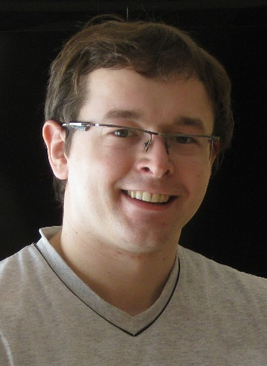
Łukasz Dydek

Address: ul. Szarych Szeregów 3/25, 35 – 114 Rzeszów, Poland
Birth date: 5th of June 1985
Phone number: (+48) 796 234 442
E-mail: lukaszdydek@gmail.com
Skype: lukasz_dydek

EDUCATION
2011 – 2012 Postgraduate course in interpretation at the Tischner European University in Cracow.

2004 – 2009 MA course in English at the John Paul II's Catholic University of Lublin; specialization: linguistics and translation theory.

LANGUAGES

English – C2 (proficiency)
- German – A2/B1 (pre-intermediate)
- Irish – A1/A2 (beginner)

EXPERIENCE
2013 – till now Freelance translator, interpreter, editor, and teacher of English (owner of company Language Service Łukasz Dydek) – based on my experience and skills, as well as on resources (CAT software, dictionaries, etc.), I provide my services the best I can. Currently I am a full-time contractor for EuroLingo Translation Company. I deal with translation and revision jobs in the following general fields: IT, mechanics, construction, energy, automation, automotive, marketing and law. I also cooperate with United Language Group (based in US and IRE) and Contrad (based in PL).

2013 – 2015 English teacher at SPAR Poland (teaching executive staff of SPAR Poland).

2011 – 2013 English teacher for „Germanitas” School of English (teaching executive staff of Bać Pol S.A.).

2010 – 2011 English teacher for "YES" School of English (teaching Secondary Junior School pupils in a EU financed programme).

2007 – 2013 Full-time translator and proofreader for Skrivanek Poland Sp. z o.o. (English
->Polish and Polish->English) (translating texts on various topics from different fields, for example: contracts, in-house documentation, user manuals, technical documentation, promotional materials, websites, videos, etc.; participation in translation projects).

2009 – 2010 English teacher for Jan Kochanowski University in Kielce, Poland (conducting Practical English classes).

2007 English teacher in a course on British culture and English language for children as a part of voluntary work for Polskie Stowarzyszenie Pedagogów i Animatorów „Klanza”; also a co-creator of the course.

2006 and 2007 Interpreter (traineeship) at the International Job Fair in Lublin, Poland (interpreting job interviews, interpreting queries of persons looking for a job abroad, as well as foreign employers' answers to these questions).

SKILLS
- Training in CAT software: SDL Trados 2006 and Across 5.0 (2010),

- Training in English teaching, creative writing, and literature for the best English MA course students held at St. Mary’s University College in London (2008),

- Voluntary work (teaching of English, for example teaching an English student with disability English grammar at the advanced level) (2006 – 2007),

- Computer skills: MS Office 2013, Open Office; MS Outlook, Adobe Acrobat; 7 Zip; Trados Studio 2011 and 2014, Alchemy Catalyst Translator/PRO 10.0, Wordfast 5.61k, OmegaT, TStream editor (*.lwa files), Across 6.3, Idiom WorldServer, Memsource Editor, Adobe Linguistic Tool; ABBYY Fine Reader Professional 11 PL.

- Valid driving licence, B category (2003).

ME AS A PERSON
- reliable and meticulous
- having sense of humour
- open to new situations
- flexible

INTERESTS
- IT (in general)
- corpora
- new technologies
- mobile technologies
- road construction
- progressive and thrash metal

