Nelly Olga Popean Matthews

7 Exeter Crescent Telephone: 0064 27360 4565
PALMERSTON NORTH Email: nellymatthews59@gmail.com
New Zealand Secondary email: npopean2004@yahoo.com

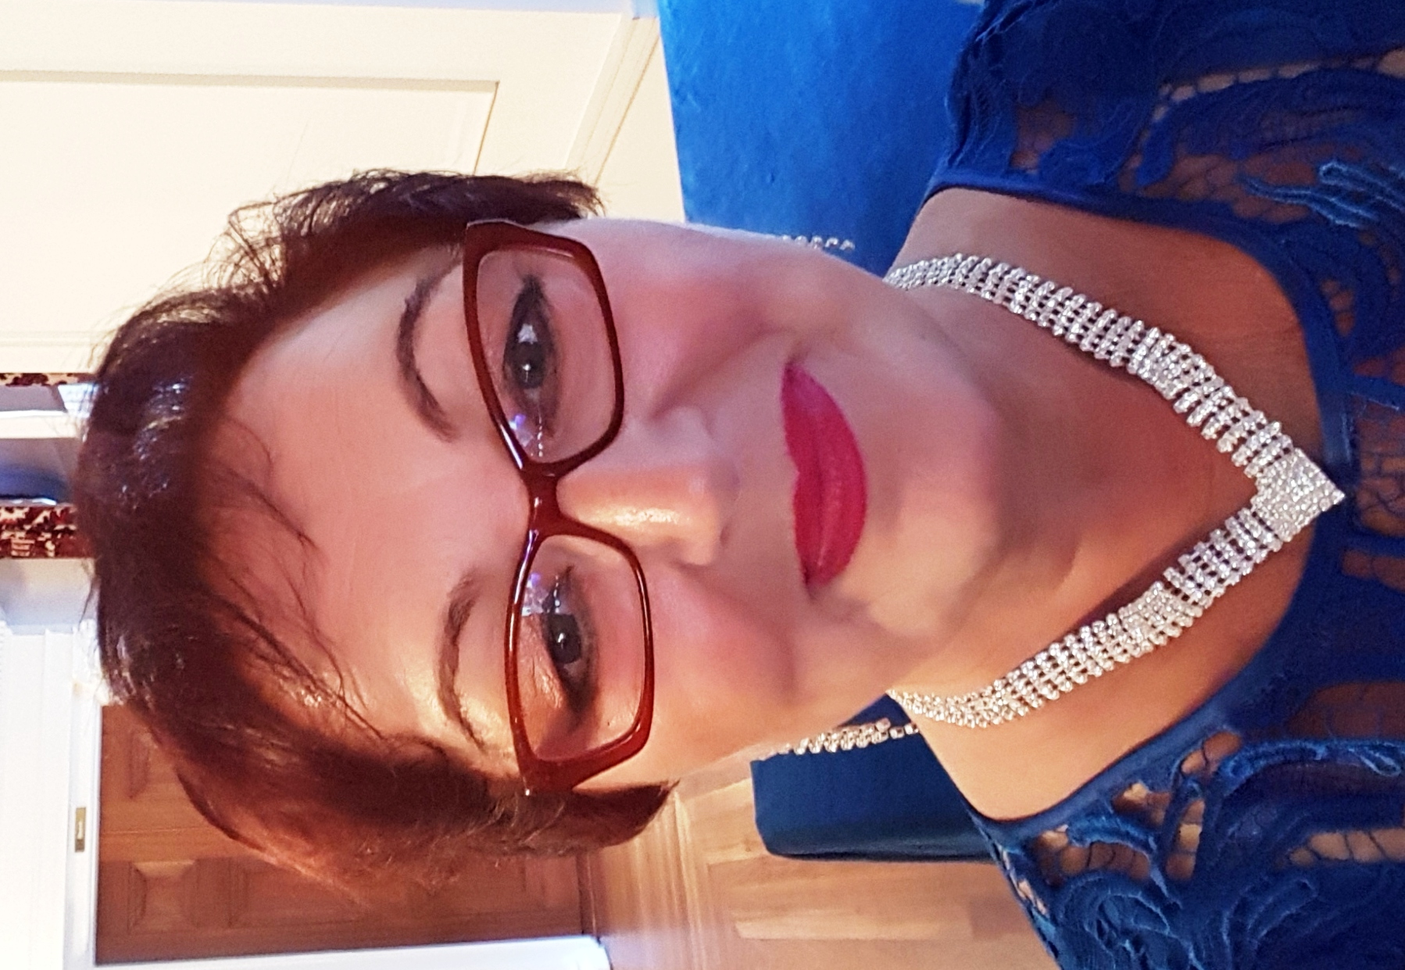
Academic Achievements:
- 2006 –2008 – Bachelor of Education (TESOL), Massey University, Palmerston North, New Zealand
- 2005 – NZQA National Certificate in Business Administration and Computing, UCOL, Palmerston North, New Zealand
- 1995-1998 – Bachelor of Arts, “Phoenix” Post Secondary Institute, Cluj-Napoca, Romania, major Law – specialty Romanian-English-French legal translator/interpreter. Licence No. 4131/2000 issued by the Ministry of Justice Romania.

Work Experience:
- 1998 – present - Freelance translator/interpreter English-Romanian-English
- 2008 – 2015 – part time English Teacher at ETC Palmerston North
- 1998- 2003 – Translator/Teacher, SC Britania SRL Cluj-Napoca, Private School of Foreign Languages, Romania
- 1995-1998 – Headphones translator/subtitler, Double Max TV Station, Romania

Memberships
- Member of NZSTI (New Zealand Society of Translators and Interpreters)
  - Member of ProZ.com; profile at http://www.proz.com/profile/578494;
  - ProZ certified and verified. PRO certificates EN>RO and RO>EN

Publications and voluntary work:
- Taught English to immigrants (ESOL Home Tutor Certificate)
- Translated the Treaty of Waitangi - the founding document of modern New Zealand - and was published in the book Treaty 30 Times

WORK EXPERIENCE:

2004-present – Freelance translator and interpreter New Zealand

I have 16 years experience as a translator in two different countries. My main specialty is legal (contracts, regulations, arbitration, criminal law, witness statements, forensic reports, intellectual property and others) but I translated in other fields as well like medical, certificates, letters, diplomas, medical questionnaires, clinical trials related documents, technical, business, human resource documents, education, social sciences, life sciences, government/politics, financial, medical general, website localization, environmental reports, feasibility studies, marketing, corporate presentations, and other general. The contract with Lionbridge gave me the opportunity to work implicitly for the European Parliament. In the last five years, I worked a lot on clinical trials related documents, lab tests and medical procedures, pharmaceuticals and back translations (RO>EN).

1998 – 2003 S.C. “BRITANIA” S.R.L Cluj-Napoca, Romania
Romanian- English-French legal translator/interpreter and English Teacher

I worked with this company for five years. In Romania, as a legal translator, I translated different official and personal documents into/from English, French and Romanian. I also translated from different domains as: legal, technical, financial, medical, marketing, IT, accounting, websites, communication, HR, sociology, and education. I usually do a lot of research for my translations to make sure I deliver quality and reliable work on time.

LANGUAGES SPOKEN
Romanian, English – native languages (bilingual), expert user
French – reading, writing, speaking - very well

Computer Skills:
Microsoft Office 2013, Internet, Email, SDL Trados Studio and MultiTerm 2017
Main clients:
Lionbridge, Ireland (European Parliament) – verbatim reports RO>EN, life sciences projects, medical, pharmaceuticals, clinical trials related documents (e.g. Carmelina Clinical Study, Quintiles Intarcia)
Transperfect, New York and London - mainly medical and legal (RO>EN; EN>RO)
Language Insight, UK - market research questionnaires (e.g. Vodafone, Duodopa), medical, software testing (RO>EN; EN>RO)
Bostico International, England – legal, technical, medical, diplomas, certificates, letters, marketing, financial, HR, and others (RO>EN; EN>RO)
Czexpress International – mainly legal, certificates, diplomas, letters, technical and corporate
e-reputation Dacia presentation magazine (RO>EN; EN>RO)
Global Languages, US – mainly medical and legal (RO>EN; EN>RO)
Lingo Systems US, (Cornerstone on Demand website localization and testing) EN>RO
Eteams, Ireland (Eurofound) – reviewing EU documents – EN>RO
NZTC International, New Zealand – mainly legal and financial docs - (RO>EN; EN>RO)
North Shore Immigration, New Zealand – documents for immigration (RO>EN; EN>RO)
Dynamic Languages, US - legal + medical documents - EN>RO; RO>EN
Rossion, Canada – Localization of clinical trials and national food lists into EN NZ, website localization and testing
MLT Christchurch - certificates, letters (RO>EN; EN>RO)

REFEREES:

Andreea Bostan

Bostico International, UK
MSc, S.A.C Cert, RPSI, M.C.I.L
NOTARY PUBLIC
Senior Linguist
www.bostico.co.uk
Tel: 0845 388 9263
andreea@bostico.co.uk

Simona Woodberg

LICENSED ADVISER (IAA 200800958) | NORTH SHORE IMMIGRATION

p. (+649) 415 3392 | f. (+649) 415 5934 |

Email: sim@nsis.co.nz

Director | NZ Association for Migration & Investment (NZAMI)

