Aída Margot Pacheco  Mother tongue: Spanish (Venezuela)  Phone number: +58 (212) 276-8301  Mobile: +58 (412) 952-7230  aidapacheco@translatorit.com  www.translatorit.com  Caracas - Venezuela | 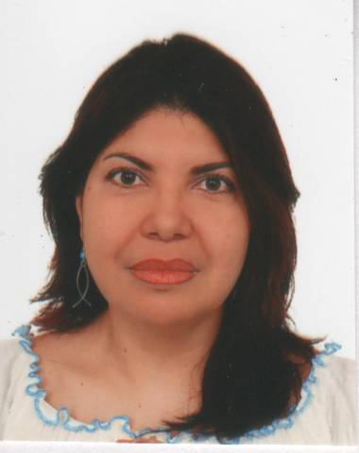

Education

- Diploma in Translation (DipTrans). Universidad Central de Venezuela. March to November 2007.
Subjects attended and passed: Translation and Traductology – Style and Syntaxes – Terminology
and Documentation – IT and translation. Fields of Translation: legal, literary, and politics.
- Legal Translation Program. Universidad Metropolitana. 315h. October 2005 to November 2006.
- General Translation Program. Universidad Metropolitana. 128h. May to October 2005.
- Diploma in Teaching. UNEFA. April to July 2008.
- Associate Degree in Administration, majoring in Tourist Services. Colegio Universitario de Caracas.
July 1998.

Membership

- Translators and Interpreters Metropolitan Association (AMTRADI). Caracas - Venezuela
- ProZ: http://www.proz.com/profile/564705

Web site: www.translatorit.com

Skills

Customer service orientation, confidentiality and dead line conscious, responsible, interpersonal relationships.

Main Customers

Adriana Álvarez Belloso Traducciones. Caracas, Venezuela. Phone number: 58-412-3325620.
Freelancer Translator. Nov. 2006 – at present. Business, corporate, legal, financial, insurance, technical, engineering, sociological, humanistic, and civil documents translations, among others.

SP Traductores, C.A. Caracas, Venezuela. www.sptraductores.com. Phone number: 58-212-2839698. Contact person: Tr. Mrs. Luilla Molina. Position: Freelancer Translator. October 2007 – at present. Medical, scientific, and pharmaceutical translations.

Abroadlink Corporate Translation and Localization Services. Granada, Spain. http://www.abroadlink.com
Contact person: Tr. Mr. José Gambin. Position: Freelancer Editor. August 2009 - at present. Editing web sites and leisure activities texts into Latin-American Spanish.

Grupo Farma (Pharmaceutical Laboratory). Caracas, Venezuela. Abril 2002 – Abril 2009.
Bilingual Assistant. Functions: Updating the web site www.grupofarma.com, by editing Spanish corporate, marketing, publicity, and scientific texts, translating said texts into English and inserting images. Editing and translating Spanish and English legal, financial, and scientific documents produced by the Corporate Directors, as well as statements, reports, and memoranda submitted by the Corporate Auditor.

Further experience

Audiovisual, New Age, Scientific and IT Papers, and Gastronomy translations, among other. Spanish and English Teacher for adults and kids. Spanish<>English Proof reader.

Further education

- Problem solving and Creativity. The brain in EFL. 4hs. MacMillan Venezuela. January 2010.
- Learning to Learn and Fifteen Ways to Attack a Text. J.J. Wilson. Pearson Longman Venezuela. April 2010.
- Frequent mistakes when translating into Spanish. 4hs. La Casa del Traductor. June 2009.
- Preparation Workshop for presenting the ATA examination. 4hs. La Casa del Traductor. June 2009.
- Legal translation and Documents legalization. A.C. CONALTI. 8h. June 2009.
- Audiovisual Translation. Universidad Central de Venezuela (UCV). 48hs. Feb – May 2009.
- Translation reviewing. Prof. George Bastin. 8hs. AMTRADI–UNIMET. January 2006.
- Spanish<>English Written Translation. NELS. Caracas - Venezuela. 116h. September 2000 – January 2001.
- Intensive Communicative English. NIHERST. Trinidad and Tobago. August 2000.
- Business English. The British Council. Caracas - Venezuela. October – December 1997.
- Advanced Writing Skills I and II. NELS. Caracas - Venezuela. 1992.
- ESL. University of the West Indies. Trinidad and Tobago. 1991.
- Knowing your competencies. Grupo Farma. October 2004.
- Training for Instructors. INCE. 2000. Caracas-Venezuela.
- Effective Communication. INESTED. October 1999. Caracas-Venezuela.
- Attention to Customer. INESTED. October 1999. Caracas-Venezuela.
- Team Cohesion and Productivity. Calzadilla & Assoc. 1993. Caracas-Venezuela.
- Personal Productivity and Time Management. Prunhuber & Assoc. 1990. Caracas-Venezuela.
- Public Speaking. Ceprovoz. 1986. Caracas-Venezuela.

Hardware and software

Main system: Intel® Pentium® 4.3.0GHz, 80GB hard disk, 512 MB RAM, CD-ROM/CD-RW, printer/scanner Epson Stylus CX3700, DVD/CD-RW. Broadband Internet access. Windows XP, Office 2007 (Word, Excel, Power Point, Publisher, Paint, etc) and Transtation. Anti-virus system.

Sources of consultation

- Personal glossary
- Diccionario de la Real Academia Española and Diccionario Panhispánico de Dudas.
- Diccionario de Términos Jurídicos by Enrique Alcaraz Varó.
- Diccionario de Términos Económicos, Financieros y Comerciales by Enrique Alcaraz Varó and Brian Hughes.
- Diccionario de Términos Legales by Louis Robb.
- Diccionario de Ciencias Jurídicas, Políticas y Sociales by Manuel Ossorio.
- Diccionario de las Dudas del Español by Fernando Navarro.
- The Internet, with its invaluable sources and parallel documents.

