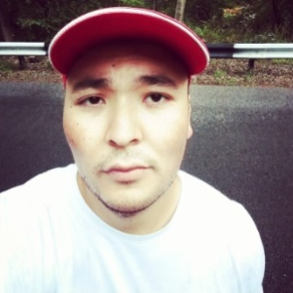 |  | Bakhytzhan Serikov  Male, 33 years, born on March 18, 1990  +7 (775) 420 99 86 (WhatsApp/Telegram), skype: brooklyndodge  bakhytzhanserikov90@gmail.com  Reside in: Almaty, Kazakhstan  Citizenship: Kazakhstan
Work experience — 9 years 1 month
November 2021 — till now  1 year 9 months |  | Freelance  Freelance translations  Translation of various technical, legal, financial, and other documents for translation companies in Kazakhstan, CIS and beyond.
July 2014 — October 2021  7 years 4 months |  | Ace Translations Group LLP  Almaty, ace-translations.kz  Translator  9 years of vast experience in providing translation services from English to Kazakh/Russian as part of the major projects mainly implemented in Kazakhstan, CIS and beyond. I specialize in oil & gas, mining, electronics, motor vehicles, instrumentation & controls, legal and banking documents, IT, chemicals, laboratory studies and medicine, textbooks and training materials, games, etc. I am proficient user of various CAT & CAD tools, including SDL Trados Studio, Translation Workspace, Smartling, SmartCAT, Memsource, MemoQ and AutoCAD, as well as general office software.
Education
Higher
2012 |  | North Kazakhstan State University named after M. Kozybayev, Petropavl  Philology, Foreign language: two foreign languages
Key skills
Languages |  | Kazakh — Native  English — C2 — Fluent  German — B2 — Upper Intermediate  Russian — C2 — Fluent
Skills |  | Written translation Technical Translation Trados Legal translation AutoCAD MS Office
Additional information
I can provide translations from English / Russian / Kazakh into Russian / Kazakh and reliable translations into English.
Projects participated:
FGP/WPMP Projects
TCO Assets Development Projects (SGP/SGI)

