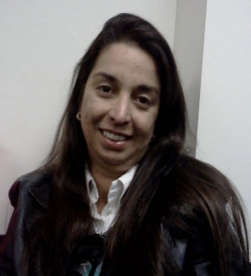
Denise Moura
Av. Alvaro da Cunha Barros N°673 apto 301
Miguelopolis – SP
Brazil.
CEP 14530-000
E-mail: denisebmoura@gmail.com
Tel. 55 (16)99613-4928
Availability to travel and reside in other cities

I – Introduction

I’m based in Miguelopolis – São Paulo, Brazil, I am graduated in the career of ​​business administration, I completed the higher course lasting 04 (four) years, bachelor's degree at the end of December 1992 from UNIUBE (University of Uberaba) in Uberaba-MG, Bachelor in Business Administration, administrator registered under No. CRA/SP 96022, currently with a MBA in Business Management from Institution FGV, I intend to work in the Business Management area, exercising the profession, as soon as I have an opportunity, I have great knowledge about administration generally.

II – Professional Experience

- Freelance Translator from English into Portuguese (BR).

- Volunteer Translator On YouVersion.com.

- Managing partner at Primavera Praia Clube.

- Experience as a teacher in the discipline of Business Management at the State Technical School Laurindo Alves de Queiroz – Centro Paula Souza.

- Professor in the PET program with Technical Workshop in Commercial Transactions by SENAC 30hours.

- Knowledge of word, Excel, cloud systems, easy adaptation to any system, programs that manage companies.

III - Courses and Lectures

- Translation Mentorship
- MBA course in business management from FGV.
- Creative and Strategic Sales Communication – IBB.
- Marketing Dynamics and Creativity – IBB.
- Company Directors – IBB.
- Marketing and Advertising Technique – IBB.
- Marketing and Advertising Technique – SEBRAE.
- Advanced English. I’ve already taken an English course and I lived
for one year in the U.S
- I’ve been working on YouVersion Localization Crowdin platform as a volunteer.

IV – Strategic thinking

Today in the market, we need professionals of the highest quality, whether to exercise a position of leadership, trust, and others, this is what entities that aim for growth in general seek, we graduate, we are with this same desire to grow, which together with these companies that open spaces for us, we believe to achieve, overcoming all obstacles that may arise ahead, whatever they may be.

V – Strong skills

Proactive, dynamism, organization, commitment and involvement in the company. Ease of working in a team and in interpersonal relationships.
Communication and expression skills.

VI – Personal goal

I intend to work in the areas of Marketing; strategic planning; sales and negotiation or hospitality; tourism, at management levels; coordination; supervision or direct assistant.

Miguelopolis - SP, June 10th, 2022.

Denise Moura Jorge

