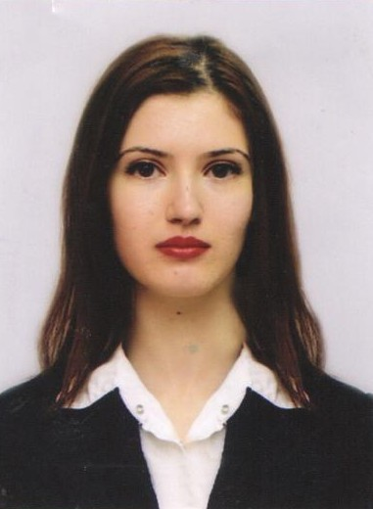

Personal information: Marina Dimitrova Tsaneva

Phone number: 0899100342

E-mail address: dimitrova_marina@mail.bg

Work Experience:

09.11.2021 – to present A Data Pro

Research Analyst with English and French

- Due Diligence, Risk and compliance checks of companies

05.03.2019 – 03.02.2021 Translate Plus

Project Manager

- responsible for all stages of the project cycle of various linguistic services: scheduling,
budget estimate, linguist selection and ensuring the quality of the translated text;
spellcheck/editing of texts in English and French;

30.11.2016 - 28.03.2018 Sutherland Global Services

- Support Consultant with French for 2 vacation rental websites
( Abritel.fr, Homelidays.com)

07.04.2015 - 19.06.2015
Ilyan.com

Digital marketing trainee

- Social media marketing, community management, Facebook content creation for different brands (Tefal Bulgaria, Arm & Hammer, etc.)

16.06.2014 - 16.12 .2014
Net It Ltd.

Marketing assistant

- Creating content for digital marketing e-courses; writing promotional materials, incl. body copy / call-to-actions for online ads and banners;

Education

2020 – (currently)  2008 – 2012 | Sofia University "St. Kliment Ohridski "- "Translation Studies" (M.A)
 | University of National and World Economics - "Political Sciences" (B.A)
Languages
 | Understanding |  | Speaking |  | Writing
 | Listening | Reading | Spoken interaction | Spoken production
English | C1 | C1 | C1 | C1 | C1
French | B2 | B2 | B2 | B2 | B2

