Curriculum Vitae

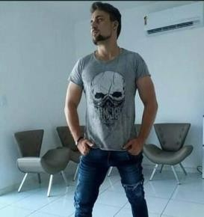
Name: Raimundo Nonato Robert Moura de Freitas

Birth Date:
14/11/1990
Gender: Male

Nationality: Brazilian
Phone: (88)9255-8731 / ( ) -
Marital Status:: Single
Email: robertlivesnovel@gmail.com

Street: Vilmar de Oliveira Andrade
Number:
1953

District:
José Simões
City: Limoeiro do Norte
U.F.: CE

Professional Experiences

Company Name: Highlight Calçados Position held: Salesman and Stockist
Admission: 11/06/2014
Resignation: 08/18/2015
Observations: I had to travel

Education
Education: Higher Education
Description: English Letters
School / Institute: FAFIDAM UECE

Courses
Course Description: Basic Computing
Notes: More than 300 hours of class
School / Institute: Course Duration:mNit Centec 1 Year
Course Description: English Advanced Level
Observations: Almost Native Level
School / Institute: Course Duration:,Online Courses São Paulo 1 Month
Course Description: English Literature Observations: A Deepening in the Study of Literature

Institute: UNIEDUCAR
Course Duration : 1 Month
Course Description: Introduction to Research Methodology
Observations: Academic Research

School / Institute: Course Duration:
Documents
FGV-Online
1 Month

Professional Card: 0174489 Electoral
Title: 0805 6596 0744

R.G .: 2007209482-0
C.P.F .: 066.420.273-02

"I am available for an interview or possible hiring."

