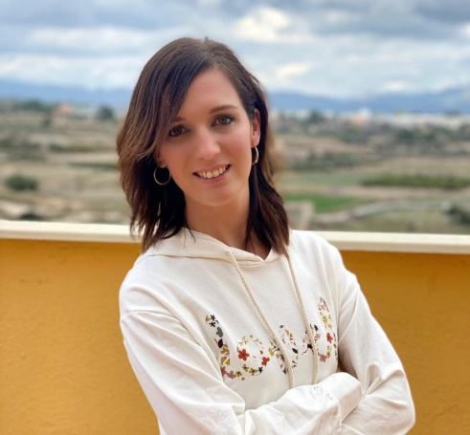

**TRANSLATOR / AUDIOVISUAL / GAME LOCALIZER**

**EN / FR / SP / VAL**

**WORK EXPERIENCE**

**CELIA CONTRERAS CANTÓ**



**BOOKING.COM (AMSTERDAM) | TRANSLATOR**

Currently

* Translation of texts for its website.
* Language pair: EN > SP.

**AC ESTUDIS (VALENCIA) | AUDIOVISUAL TRANSLATOR**

Jul. – Aug. 2008

* Translation of *Les Canopus* cartoon seriesfor the Valencian television.
* Language pair: FR > VAL.

May 2008

**FUNDACIÓN PREMIOS REY JAIME I DE VALENCIA | INTERPRETER**

* Whispered interpreting (*chuchotage*) for the winner of the Urbanism, Landscape and Sustainability award.
* Language pair: SP > FR.

**MOSTRA CINEMA MEDITERRANI (VALENCIA) | INTERPRETER**

SALLE DE SPORT

Nov. 2006 - Nov. 2008

* Simultaneous interpreting in the opening and closing ceremonies.
* Consecutive interpreting in press conferences involving actors –including Don Johnson and Raquel Welch- and directors.
* Language pairs: EN / FR > SP and SP > EN / FR.

**DEMIPAGE - PUBLISHER (MADRID) | TRANSLATOR**

May – Jul. 2007

* Translation of textbooks.
* Language pairs: SP > VAL.

**ENIL MAMIROLLE (FRANCE) | TECHNICAL TRANSLATOR**

Nov. 2006 – Jun. 2007

- Feb. 2018

* Technical translations for a cheese manufacturing company.
* Language pairs: FR / EN > SP and FR > EN.

**EDUCATION**

**AUDIOVISUAL TRANSLATION: DUBBING AND *VOICE-OVER* / TRÁGORA FORMACIÓN (GRANADA, SPAIN)**

Feb. – March 2021

. Finalización

- Feb. 2018

Online course (80 hours). Specialization in dubbing and voice-over techniques for all kind of audiovisual formats.

**VIDEO GAME LOCALIZATION / AULASIC (BARCELONA, SPAIN)**

Nov. – Dec. 2020

Online course (40 hours). Specialization in translation techniques for all video game genres. Tags and variables management.

**M.A. TRANSLATION AND INTERPRETING / CENTRO UNIVERSITARIO ESTEMA – UMH (VALENCIA, SPAIN)**

2001 - 2006

* General translation
* Audiovisual translation
* Video game localizatin
* Web localization
* Technical translation
* Proofreading
* Post-editing
* CAT Tools: Memsource

linkedin.com/in/celia-contreras-cantó-627653205

contreras.canto@gmail.com

email

Valencia (Spain)

(+34) 645 91 93 20

**CONTACT**

Spanish and Valencian native speaker with translation experience in the language pairs EN>SP-VAL, FR>SP-VAL, VAL>SP, SP>VAL.

I have devoted the last years of my work experience to teaching. I have worked in different educational stages in Spain as well as in the USA.

**ABOUT ME**

**SERVICES**