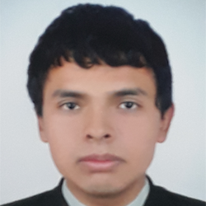
Jholvy Sarmiento Torres
Address: Av. Paris 703 – Jacobo Hunter, Arequipa
Contact phone: +51 973173790
E-mail: jholvysarmiento@gmail.com
_________________________________________________________________
PROFESSIONAL FORMATION
2016-2018: Graduate in Computer Science
IESTP “Honorio Delgado Espinoza”
WORK EXPERIENCE
Pre-professional practices in the “UGEL Sur Arequipa”
November, 2016 – February, 2017: Informatic office
PC maintenance.
Technical assistance in offices.
December, 2017 – March, 2018: Informatic office
Data update in the SUP.
Data update in the SisGeDo.
INFORMATIC APTITUDES
Basic knowledge in web design using HTML5, CSS and JavaScript.
Basic knowledge in web development with WordPress.
LANGUAGE
English:
Certificated by R.D. N° 361-2018-DG.IESTP.HDE

