sammyliu200118@gmail.com

Name: Sammy Liu
Place: China
Languages: Chinese, English, Japanese, Korean
File types: PDF, docx, pptx, xlsx, jpg, png, gif, tiff, etc.
Good quality, good layout, accept urgent tasks.

Sample translation as below:
==========================
In 2016, China had 442,431 international students, a 35 percent increase over 2012. China now ranks third in attracting foreign students after the United States and the United Kingdom. With Chinese universities climbing up the global rankings, their rapid internationalization, policies encouraging foreign students to study in China, and affordability of study and living costs compared to the West, China will soon become the top destination for international students.
Of 5 million international students pursuing higher education courses outside their home countries, nearly 25 percent are Chinese. In 2016. American universities attracted 330,000 Chinese students, followed by 166,000 from India. The increasing numbers of Chinese students abroad and foreign students in China will further enhance its soft power.
In terms of culture, Italy, with 53, has the largest number of UNESCO World Heritage sites, China comes next with 52. Some 138 million tourists Visited China in 2016. Similarly, 122 million Chinese visitors went abroad in 2016.

2016年,来中国的留学生数量为442431人,相比2012 年增加了35%。在吸引海外学生方面,2016年,中国排名第三,仅次于美国与英国。中国大学国际排名的攀升和高速的国际化,吸引留学生的政策,以及较西方国家低廉的学费与生活开支,使中国不久将成为国际学生的首选国家
全球到海外接受高等教育的 500万留学生中,近25%来自中国。2016年,美国大学吸引到了33万名中国学生,其次是16.6万印度学生。海外中国留学生与国内外国留学生数量的不断增长将进一步提升中国软实力。
在文化层面,意大利有53处经联合国教科文组织认定的世界文化遗产,数量最多,中国则以52 处位居第二 2016年,中国接待了约1.38亿游客。同样,中国的出境游人次达1.22亿。
==========================
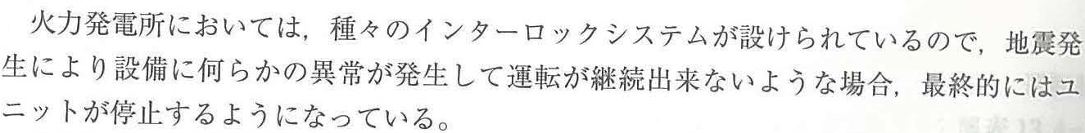

In thermal power plants, because various interlock systems have been provided, in the case if any abnormality occurred to the equipment due to the earthquake and the operation cannot continue, the unit will eventually stop.
==========================

