**GORAN**

**ANDOV**

Contact

**Address:**

Aleksandar Makedonski 10;

Kocani 2300; Macedonia

**Phone:**

+389 (0)78 666 994

**Email:**

gokobvb@gmail.com

Languages

English – C2

Macedonian - Native

German – C2

Spanish – C1

Serbian – C1

Polish – B2  
Italian – C1

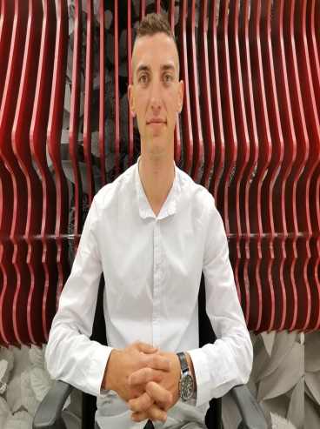

Summary

I am a passionate and experienced teacher of English and German. I am also a polyglot, with an extensive knowledge of both English and German, as well as a high level of Italian and Spanish. Moreover, I am a professional in the field of translation, with a career spanning more than 8 years already, having translated all kind of texts, from general to technical and medical.

Skill Highlights

|  |  |
| --- | --- |
| * Innovative teaching * Strong decision maker * Complex problem solver * Professional translation services | * Ambitious * Innovative * Service-focused * On-time delivery and deadline-oriented |

Experience

**Teacher of English and German** - 09/2017 to 09/2018

**“Access”, school of foreign languages**, Skopje

**Private teacher of English and German –** 09/2018 – until today

* Cooperate with other professional teachers to make learning interesting, comprehensible and fun.
* Taking part in seminars for teachers.

**Freelance translator on Proz.com –** 01/2013 – until today

* Translation for big translation companies, including: Synergium / Eurabic / ALM translation / Promosaik / Expertrans and so on.
* I have worked on many big projects including: 300.000 words on MTPE and HR Twitter Project for Synergium, 260.000 words on Legal suits documents for Promosaik, 170.000 words on Landing page – email marketing for Expertrans
* I work with a professional CAT tool and memory software – Trados 2021 (latest version)

Education

**Bachelor of English language and literature: Teaching English,**

Faculty of Philology “Blaze Koneski” – Skopje, Macedonia

Certifications

* BA in English language and literature – English teacher
* Goethe Zertifikat C1 – Certificate of C1 level in German, acknowledged worldwide