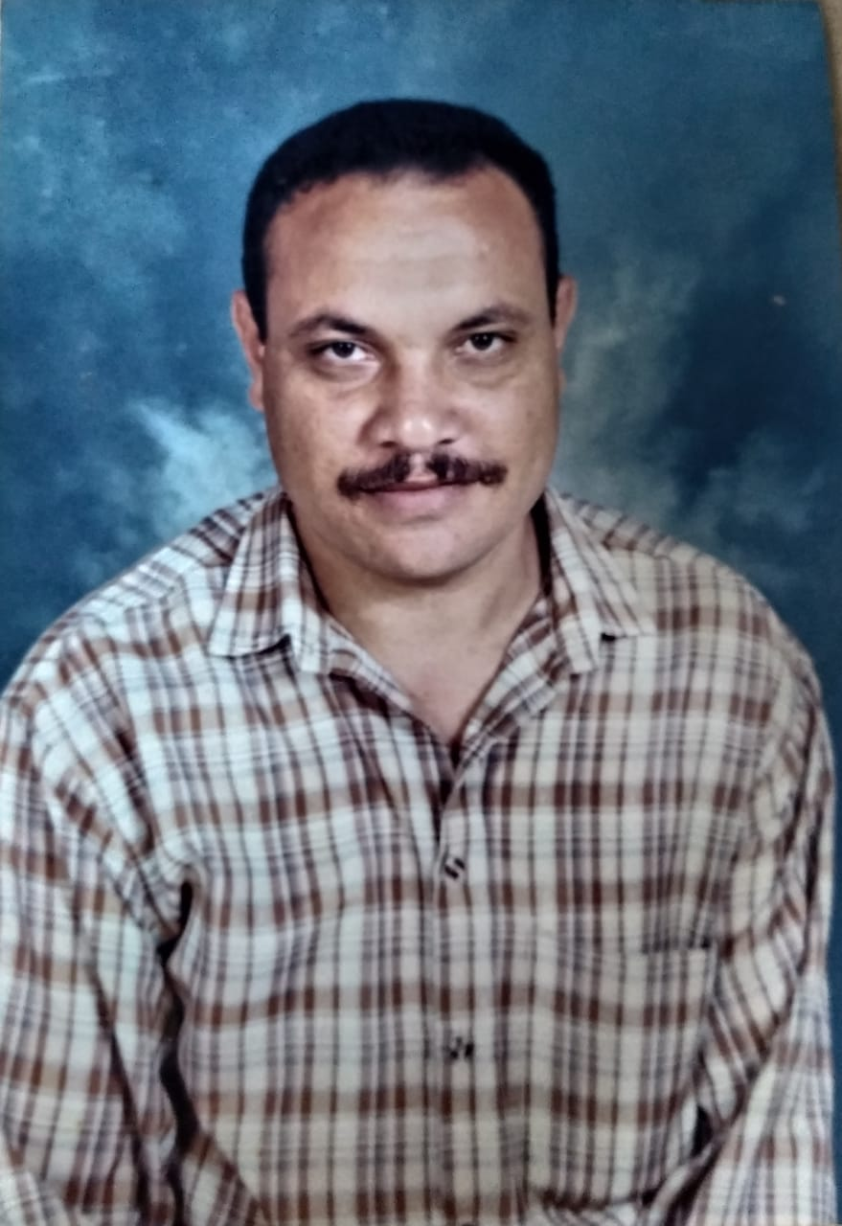

Cv
FullName
Adel Mohamed Abd elfatah Almergawy
Title
Adelalmergay
Contact information
Adelalmergawy@gmail.com
00203/ 01204526969/Egypt
Personal information
Address
66 st . no.2 Sidibshr,Alex,Egypt
Date of birth
:4/12/1961
Services: Translation, proofreading , transcription, editing , writing and teaching
Degrees: Bachelor of Arts and Education , Faculty of Education, Alexandria university , English Department!987
I have got a certificate in methadology ( courses ) and communicative skills at the Alexandria Inset Centre, Egypt. I have got also a degree in Inspection.I have been teaching English for secondary schools.
Working Languages

English to Arabic
Arabic to English
Arabic (monolingual)

Skills and duties
I am clever at writing . I have done many different writing projects. I am good at transcription. I have the skill to translate from Arabic o English and vice verse.I am always obliged to carry out the required projects perfectly and properly o time.
Hobbies:
Reading English articles, watching and listening English videos.

