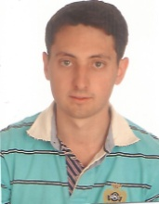

PERSONAL INFORMATION :

First Name, Name : Cedric Fructueux
Birth : 15 December 1991 in Dax (France)
Address : 406, rue des bouvreuils, 40560 Vielle Saint Girons - France
Phone : (+34)635875175
Mail : kike-8@orange.fr

EDUCATION :

- Higher national diploma "water's jobs" (Chemical engineering) : may 2012 in Dax (France)
- Scientifics' baccalaureate : June 2010 in Dax (France)
- Languages : - French : mother tongue
- Spain : bilingual
- English : baccalaureate's level

WORK EXPERIENCE :

- Translator and proofreader for Global Alumni company since November 2020.
- Translator and proofreader for Pangeanic company since May 2020.
- Translator and proofreader for CCJK company since May 2020.
- Translator and proofreader for La fábrica de traducciones company since April 2020.
- Translator and proofreader for Gear Translations company since February 2020.
- French teacher at home since April 2019.
- Translation, transcription, proofreading, subtitling and voice over in Spanish and French for professors to prepare their diplomas since 2015.
- French teacher for Strugal company (Sevilla) : may at august 2018.
- French teacher for Childbis academy (Las Cabezas de San Juan (Sevilla)) : since November 2016.

