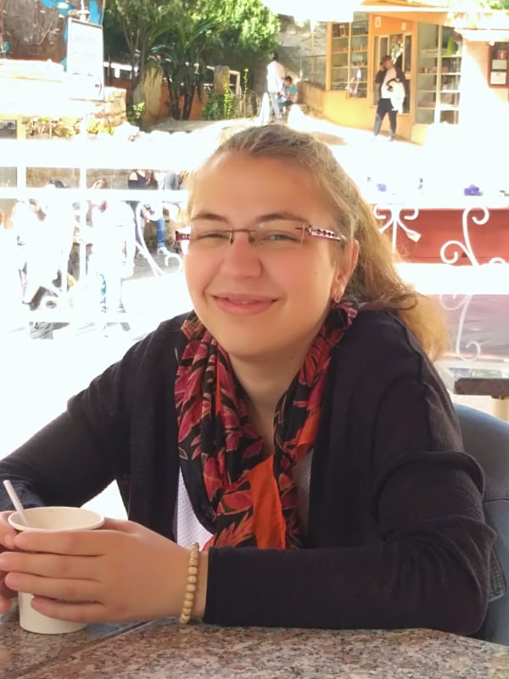
CV of Ms. Simona Handschuh
contact data:
permanent adress : Speichberggasse 84/3/7, 3002 Purkersdorf, Lower Austria/ Austria
cell phone number: 0043 650 9050 004
email adress : simonamounia@gmail.com
Personal information :
Birthdate : January 30th 1991
Birthplace : Vienna, Austria
school education :
09/1997 – 06/2001 : primary school in Purkersdorf, Lower Austria
09/2001 – 06/2009 : secondary school BG/BRG Purkersdorf, Lower Austria
(with specialisation in languages : french, latin, spanish, english)
2009 : receipt of general qualification (diploma) for university entrance
university education :
2013/2014 : one year of Oriental studies at University of Vienna
2014 – 2017 : Bachelor studies in Arabic Language and Culture at University of Lille, France
2017 : receipt of Bachelor diploma (see annex)
2018/2019 : first year of Master in Arabic Language and Culture at University of Lille, France
job experiences :
various student jobs next to my studies, voluntary jobs as translator
10/ 2019 : Interpreter in Moria, Lesvos (Greece) with Seprotec – Multilingual Solutions and EASO (European Asylum Support Office)
additional education apart from university :
2011-2014 : attendance of extra arabic courses next to job/ studies at Sprachenzentrum Wien (see annex)
2017 : receipt of CLES, Level 2 for Arabic (Language Competency Certificate in higher education), University of Lille, France (see annex)
2017/2018 : one year of intensive courses in Arabic at the IFPO (Institut Français du Proche Orient) in Beirut, Libanon (see annex)
Language skills :
Native language : German
Languages mastered fluenlty (on a B2 up to C1 level according to the CEFR): English, French, Arabic (classic arabic and Levantine dialect)
Languages at a basic level : Latin, Spanish

