CURRICULUM VITAE
Rahmat Kurniawan, S.Kep., Ners

 | Personal Date
Full Name Rahmat Kurniawan  Place, Date of Birth Muba 17 Oktober 1991  Gender Laki-laki  Marital Status Single |  | 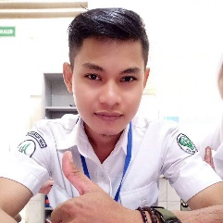 | Citizenship Indonesia  Address Jl. A. Yani. Lorong Dua Saudara, Plaju, Palembang  Phone +6285379978557  Email : 17awan@gmail.com

 | Education
Formal  2012 – 2014 Univ Sriwijaya  Medical Department of Nursing Study Program  Jl. Raya Palembang Prabumulih Km. 32, Indralaya OI, Palembang, Sumatera Selatan |  | NON FORMAL  2016 – 2018 LIA Palembang  Course English For Specific Purposes (ESP)  Program Conversation In English (CV), TOEFL Preparation (TP), and TOEIC Preparation

Experience
Scientific Editting Services 2014 - 2015
As Head of Marketing Staff - Editing Services for Health Scientific Writing in the Lubuklinggau.
Region of South Sumatra.

Editing and translating Scientific Paper 2015 – 2018
Business Owners - translating and editing Institution for scientific assignments in Palembang city.

Consultant of Scientific Paper 2018 – Now
Chairman - As a consultant scientific paper and editing of scientific works.
Engaged in editing and printing services, journaling and publications, and translate scientific papers

 |  | Ability
 | MS Office Word  MS Office Exel  MS Power Point |  | Bahasa Indonesia  English  Internet

