Curriculum Vitae
Joseph Wilson

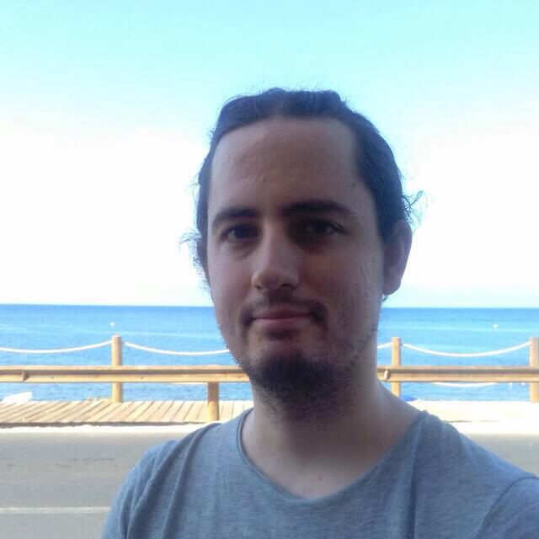
Date of birth: 21/10/1987

NIE (Spanish Foreigner’s I.D. Number): Y1435203-V

Address: Calle Galileo, 3,1,
04002 Almería.
Spain.

Email: jhw41jhw41@gmail.com

Telephone: 0034 662 53 10 11

Education

Master in the Teaching of a Foreign Language, for secondary education, from the University of Almería, Spain. 2013-2014

Degree in Modern and Medieval Languages, with translation, from the University of Cambridge, U.K.. 2006-2010

Languages

English (native), Spanish (near native), French (very high level), German (high level and experience with translations)

I am learning more languages. I will keep you informed when this becomes relevant.

Work Experience

Extensive experience with the use of Trados and Memsource (I have Trados).

Translator with Travod, London, U.K. 2019 to present.

Translator with Interleng Translation Agency, Barcelona. 2015 to present

Translator with Schröder Translations, Bochum, Germany. 2019 to present.

Occasional Interpreter, in a conference and in courts of law, Almería. 2016-2017

English, French and German teacher, individual classes. 2010-2016

English teacher in academies, Almería. 2011-2013

