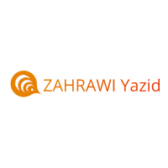
ZAHRAWI Yazid
Native French translator
Lille, France
maroc-genie@hotmail.fr
Career Focus | Translator/Editor responsibilities with a translation agency, book publisher, or newspaper.
Experience Summary | 7 years experience in the language pair English>French in the specializations:  - Legal.  - Agricultural&Food industry  - IT&web translation  - Technical, engineering and scientific documents.  - Finance&Accounting.  - Digital marketing
Education | B.A, English Literature, Lille University
 | M.A, Languages and Societies, Lille University
Professional  Skills | - Assist with copywriting and advertising layout.  - Well versed in copyediting  - Strong technical command of the English language; familiarity with virtually all writing styles; serious commitment to excellence in the printed and published word.  - Competent researcher
Computer Skills | WordPerfect • Microsoft Word • PageMaker • Ventura Publisher • Excel
CAT Tools | OmegaT 2019 • Smartcat

