Resume of
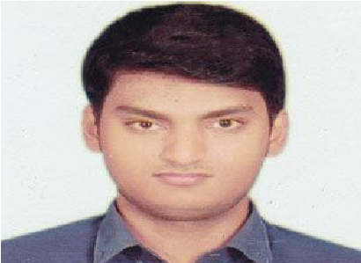
Md. Moinul Hossain
Address: L/322 Ambagan, Pahartali, Chittagong.
Cell: +8801402498537
Email: mohammadmhbhuiyan@gmail.com

In the beginning of career, I am highly desired to work in a reputed organization where I will be able to explore my capabilities and gradually develop knowledge, skill and abilities to perform duties and responsibilities efficiently and effectively to add values to my organizations where I will find ample scope and opportunity to work and to promote to a significant position.
ACADEMIC QUALIFICATION:

Bachelor of Engineering (Computer Science & Engineering)
Subject : CSE
Year : 2nd
Institute : International Islamic University of Chittagong.

Higher Secondary Certificate (HSC)
Result : GPA 4.92(Out of 5.00)
Passing Year : 2018
Group : Science
Institute : Chattogram City College Board : Chittagong.

Secondary School Certificate (SSC)
Result : GPA 5.00 (Out of 5.00)
Passing Year : 2016
Group : Science
Institute : Chittagong Collegiate School Chittagong Board : Chittagong.
Experience:
Working as a Freelance Translator(Subtitling) for the last seven months in EAM India.
Currently Working as a translator for two European Organization for last three years.
European Southern Observatory(ESO)
Translator (Youtube)
UNAWE(Spacescoop)
Translator(Article)
LANGUAGE EFFICIENCY:
Bangla: Native
English: Language of study and have the capability to speak, writing fluently.
COMPUTER LITERACY:
- MS Word,
- MS Excel,
- MS power point,
- E-Mail & Internet Browsing
AREAS OF INTEREST:
- Administrative work,
- Exploring new web sites,
- Any Challenging job,
- Reading Historical Books, Traveling
MY TRAITS:
- Capable of adopting in any type of environment.
- Confident and enthusiastic.
- Enjoy work in team and is committed to helping others.
- Good presentation ability.
- Analytical and good conceptual ability.
- Strong interpersonal and team work skill. ▪ Hard working.
PERSONAL INFORMATION:
Father’s Name | : | Md Belal Hossain
Mother’s Name | : | Akther Jahan
Date of Birth | : | 04 November 2000
Marital status | : | Single
Religion | : | Islam
Height | : | 5’ 7’’
Nationality | : | Bangladeshi by birth
Permanent Address | : | Vill. South Shibpur, P.O. Sawdagor Bazar P.S. Feni Sadar, Dist. Feni.
Reference:
Jamil As-ad
Assistant Lecturer
Department of CSE
International Islamic University of Chittagong

Mobile: 01626890190

ANOUNCEMENT:
I do hereby declare that all information stated in this resume is true and complete to the best of my
knowledge. I authorize verify the information provided in this resume

Md .Moinul Hossain

