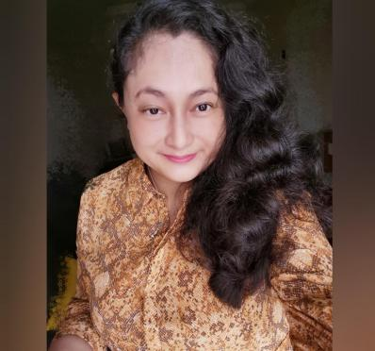Farah Liza Jamilus
Area of Expertise

1. Translating
2. Editing
3. Proofreading

Profile
Certified in translation, editing, and proofreading at Institute Terjemahan dan Buku Malaysia (ITBM) / Malaysian Institute of Translation & Books
Part timer editor for MPWS Proofreading, Bangi, Selangor, Malaysia for translation, editing and proofreading.

- Mail: farahl02771@gmail.com
Mobile Number: +60122910644
Nationality: Malaysian

Summary Skills
- Fluent in Bahasa Malaysia (Malay) and English language
- Translation, editing and proofreading
- Multitask management
- Creative problem solving
- Excellent in communication and skills
- Able to work under tight deadline and pressure
- A friendly, reliable to work systematically and independently towards results, and develop persuasive creative copy and translations and for clients.
- Highly skilled in Microsoft Office Windows, Memoq
- Keen to learn new skills and other projects

Personal Details
Studying DBA (Doctorate Business Administration) at the local University. I have attended ITBM (Institute of Translation & Books Malaysia) and move forward with my interest in translation, editing and proofreading. I have built up my client list working since 2018 and I also work as a part timer for agencies. I follow industry standards for translation, editing and proofreading into my mother tongue Bahasa Malaysia (Malay) to English and English to Malay. Besides the translation courses that I have attended, I gained more experiences in other extra projects.

Work History
Freelance Translator, Editing and Proofreader
Work Description:

- Translating, editing and proofreading from English to Bahasa Malaysia and vice versa as needed for documents/process/guidelines or company portfolio, as required by clients.
- Coordinate with the creative team, delivering projects and analysing the requirement of clients.
- Experience in editing and proofreading research proposals.

Project Details:
- Part time editor, translation and proofreading for MPWS Rich Proofreading Sdn. Bhd.
- Translating 2000 words from English to Bahasa Malaysia (Malay) for Tourist Company at Melaka, Malaysia.
- Translating, editing and proofreading academic papers, abstract including questionnaire, Company’s Portfolio or Business Documents, Education, Psychology, Technical (Electrical and Engineering) from English to Bahasa Malaysia and Bahasa Malaysia to English.
- Proofreading journals and case study for the client in Canada.
- Proofreading journals (Government P&C) for Jabatan Akauntan Negara Malaysia / Accountant General’s Department of Malaysia.
- Translating documents (Government P&C) for UNIT PEMODEN TADBIRAN DAN PERANCANGAN PENGURUSAN MALAYSIA/ MALAYSIAN ADMINISTRATIVE MODERNISATION AND MANAGEMENT PLANNING UNIT (MAMPU).
- Company Name: Altel Communications Sdn Bhd. (Under Al Bukhary Group) -Telecommunications
- Position Title: Human Resource
- Work Description: Recruitment and Training
- Company Name: Bumi Armada Berhad (Oil and Gas)
- Position Title: Human Resource
- Date Joined: November 5, 2012, to January 2013
- Company Name: Merger – Transfer of employment from SunwayMas to Sunway Integrated Properties Sdn. Bhd.
- Position Title: Human Capital Development
- Date Joined: May 2011 (Merger) to October 23, 2012
- Company Name: SunwayMas Sdn. Bhd. (Property Developer)
- Position Title: Sales and Admin
- Date Joined: July 2009

Education
- Level: General Translation Course (Kursus Penterjemahan Am)
- ITBM (Institute Penterjemahan & Buku Malaysia / Malaysian Institute of Translation & Books) – 12-23 March 2018)
- ITBM – Bengkel Penyuntingan Terjemahan / Workshop on Editing of Translation (23-26 April 2018)
- ITBM – Bengkel Pembacaan Pruf / Proofreading Workshop (9-10 July 2018)
- Level: Doctorate Business Administration (DBA)-ongoing process
University: University Utara Malaysia (KL Branch), 2014, Malaysia
- Level: MBA (General) Graduation Date: 2 Nov 2008
Field of Study: Business Administration (University Industri Selangor, Shah Alam, Malaysia)
- Level: Bachelor’s Degree (Hons) Graduation Date: Feb 2003
Field of Study: Combined Subject Program (Human Resource Management and European Studies), University of Derby, Derby, United Kingdom
Service Rates
Upon Request

