Yağız Berk Bağcı

PERSONAL INFORMATION
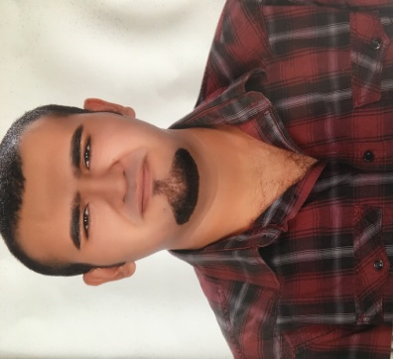
Adress: Kashirskoye Highway,Moskvoreche Street,House No : 2,Building :1,Moscow,Russia
Phone Number : +7 964 503 96 03 (whatsapp) ,+90 507 690 97 98
E-mail : yagizberkbagci@gmail.com
Date of Birth: 25.12.1993
Place of Birth: Izmir
Marital Status: Not married

Work Experiences

Academical Translation- Russian,English

National Nuclear Research University MEPhi –Nuclear Engineering

Simultaneous Translation -Izmir,Bodrum,Marmaris,Fethiye-Turkey

Personal English Teacher-Izmir-Turkey,Moscow-Russia

Personal Guitar Teacher – Izmir-Turkey,Moscow-Russia

Personal Chef – Moscow,Russia

Nilgun Dere Art Centre – Izmir,Turkey

Guzelbahce Art Centre- Izmir, Turkey

Restaurant Mesopotamia (Singer,Organizator)- Arbat,Moscow, Russia

Lale Cafe (Singer)- Moscow,Russia

Jim’N’Jacks Bar (Singer)-Moscow,Russia

Sardunya Cafe & Bar (Musician)- Izmir,Turkey

Personal Vocal Teacher- Izmir,Turkey

EDUCATION
National Nuclear Research University MEPhi, Moscow,Russia, Nuclear Engineering ,undergraduate (Russian) 2014-2018

National Nuclear Research University MEPhi, Moscow,Russia, Expert of Nuclear Engineering,High graduate (Russiam) 2018-

Obninsk Institute of Atom Physics, Obninsk,Russia, High Level Education of Russian Language 2013-2014

Izmir Institute of High Technology, Izmir,Turkey,English Mathematics undergraduate 2011-2013

SKILLS
High mathematics,high physics,tenacity,fluid mechanics,sociology,philosophy,chemics,differential equations,electrical circuits,engineering drawing ,arts,atom physics. I have a certificate of Moscow English Language Competition between universities which is organized by ROSATOM,also i have a certificate of Moscow Russian Language Competition between universities which is organized by MEI university . My level of English is equal to exam of TOEFL and my Russian level is enough to get Russian citizenship.
I met so many Russian and European tourists in my country and worked with them as simultaneous translator . On the other hand,i translated articles ,magazines,catalogues,boks etc. Russian-English,English-Russian,English-Turkish,Turkish-English,Russian Turkish,Turkish-Russian.
REFERENCES
I can give by request.

