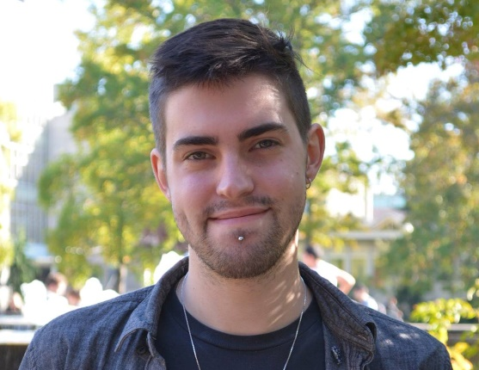
Lance Davis

| selkirktranslations.ca
| lance@selkirktranslations.ca
| +1 (778) 252-5263

GERMAN & FRENCH > ENGLISH TRANSLATOR

PROFESSIONAL  - German and French to English translator  - 3.5 years of translation experience  - Other services: localization/transcreation, proofreading, copywriting  - Rigorous research | PAST PROJECTS & END-CLIENTS  - Industrial operating manuals  - Industrial electrical systems  - Building information modelling (BIM)  - End-clients: Deutsche Bahn, General Electric, BMW, liNear, Siemens, and more
CAT TOOLS & TERMINOLOGY  - MemoQ & SDL Trados 2017  - Microsoft Office expertise  - Use of industry terminology | PERSONAL  - 7-day work week  - 15,000 words per week  - 100% on time delivery

PROFESSIONAL & TECHNICAL EXPERIENCE
Freelance Translator
- Self-employed 03/2018 – today

Treasurer of
- The Mountain CoLab Society, Revelstoke, CA 05/2021 – today

English Teacher at
- Les Pierres aux Fées, Regnier-Ésery, FR 09/2017 – 04/2018
- Friedrich-Ludwig-Jahn Gymnasium, Forst, GER 09/2016 – 05/2017

German Transcriber, Intern, at
- Auschwitz-Birkenau Museum, Oświęcim, PL 05/2015 – 08/2015

EDUCATION
Canadian Securities Course for Investors 05/2019 – 12/2019
Canadian Securities Institute, CAN

BA, Double Major in Germanic Studies (Honours) and French History 2011 – 2016
University of Victoria, CAN

Exchange Student in Germanic Studies 09/2013 – 08/2014
University of Freiburg, GER

