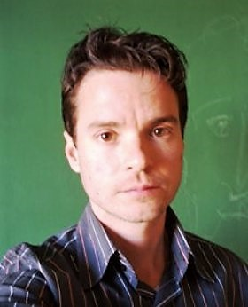
KÁJA MATĚJKA – TRANSLATOR
E-mail: MATEJKA.NAVYSOKEMEZI@GMAIL.COM
Phone: +420 775 512 217
Skype: karel_novotny3
ABOUT
I was lucky to enter the field of translation at an early age of 17 years. I started with social sciences and moved towards health care. I have been the main translator in charge of Parent Project Muscular Dystrophy Project in the Czech Republic for past 5 years. Along with that, I have gained quite a lot of experience with product texts and databases (more than 100 000 translated products until now. I translate English and German into Czech and Czech into German.
WORK EXPERIENCE
NOVASOL - Vacation Rentals Agency
PARENT PROJECT the Czech Republic – medical research news, pharmaceutical press releases, scientific articles, information sheets for patients and doctors (5 years)
ALZA.CZ - Product Texts, German Language - A complete offer for the site for Germany / Austria - 90,000 products
VYSSPA SPORTS TECHNOLOGIES - an extensive e-shop focused on sports and technological equipment, artificial surfaces, complete equipment from many sports industries
TERCIO.CZS - comprehensive and modern e-shop focused on seniors, technical aids, healthcare, electronics, health, and fitness
PORT.HU - movie database, satellite station programs
TEACHING ACTIVITY
HERMES LANGUAGE AGENCY
Individual tuition in English and German
In companies and households
Teaching small groups
TUTORING
Communication style
Tutoring in elementary school, secondary school

PEER CLUB PNB
German for people with mental illness
Creative methods
EMPLOYEE IN SOCIAL SERVICES
Separate service provision
Enhanced inclusion
Creative techniques
Reading texts

EDUCATION
NA PRAZAČCE COLLEGE
STUDIUM IN GERMANY
German: STATE EXAM (C2)
2000
ALBERT EINSTEIN OBERSCHULE BERLIN
1997
CHARLE´S UNIVERSITY - FACULTY OF HUMANITIES
2006-8
English: CAE (C1)
ART SCHOOL PILSEN
Sculptor
2012
COURSES
TRANSLATION COURSE AT TUTOR co.
2014
LINGUISTIC COURSES AT UJEP UNIVERSITY
2017
TEACHING COURSE AT OZP ACADEMY
2015
CLASSES IN PAINTING AT ZCU UNIVERSITY
2012

