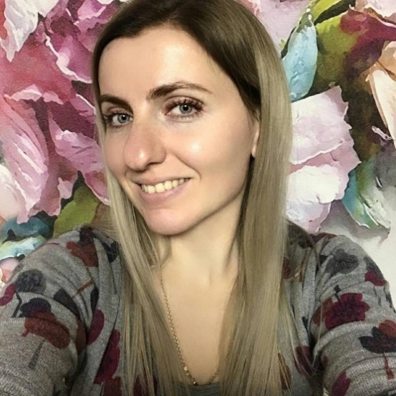
curriculum vitae
Nathalie Koval
Date of birthday – 11 March 1988
matinal.promenade@gmail.com
+380971962791

Work experience:
July 2011 - April 2013 - interpreter / chief accountant in Podillia-Travel, travel company
• Translation proofreading/translation of company website texts from/to English/German
• Translation of contracts and company legal documentation from/to English/German
• Translation and preparing of visa application documents from/to English/German
• Simultaneous interpreting during conduct of negotiations with company partners in English
• Arrange of individual and group excursions in English for foreigners
• Translation of technical documentation
• Coordinated personal errands for executives and associates
• Served as the first point of contact for clients, executives, and external partners by greeting them and answering phone or email messages
• Arranged business trips for executives by securing air and ground transportation, reserving hotels and conference rooms, and preparing itineraries
• Reviewed records for accuracy and compliance, revising of the company's handbook to reflect updated state, and company regulations

April 2013 – September 2015 translator /economist, wholesale-manufacturing company
• Translation of contracts and company legal documentation from/to English/German
• Simultaneous interpreting during conduct of negotiations with company partners in English
• Translation of technical documentation
October 2015 - interpreter/ FEA manager, O.L.KAR-AgroZooVet-Service veterinary company
• Translation proofreading/translation of company website texts from/to English/French
• Translation of contracts and company legal documentation from/to English/French
• Creating and translation of veterinary drug dossiers from/to English/French
• Simultaneous interpreting during conduct of negotiations with company partners in English/French

Freelance work
• Nikkiso, CareFusion, Zeiss, Essilor, Braun, CyDen, Biotrisse AG, PharmaResearch, Meyer-Haake GmbH, Shenzhen CosBeauty Technology Co. Ltd, Procter&Gamble, Comesa, Croma

Education:
2006 - 2010 Vinnytsia trade and economic institute of KNTEU – translator of English/German (Bachelor)
2005 - 2010 Vinnytsia trade and economic institute of KNTEU - accountant (Master)
2010 - 2011 Kyiv national linguistic university – English translator/interpreter (Master)

Special skills:
• Advanced user of such software applications as Windows XP, Windows Vista, Windows 7, Trados 2009
• Language skills: Ukrainian, Russian – native speaker, English - fluently, German – advanced, French – basic, Polish – basic, Spanish - basic

Personal characteristics: personal leadership, social skills, responsibility, operational capability, managerial skill, hopefulness, creativity

