**Medical/pharmaceutical translator experience**

**Bio**

|  |  |  |
| --- | --- | --- |
| **Yaounde** | **Freelance** | **2011-2021** |

**As a freelance medical translator, these are some recent achievements:**

- Translation of documents on Communication techniques and psychosocial intervention when counseling children survivors of sexual abuse for [Norwegian Refugee Council (NRC)](https://twb.translationcenter.org/workspace/jobs/view/id/153971#tabs-frag-4);

- Translation of documents on Identification of main malaria vector species for Médecins Sans Frontières (The Netherlands);

- Translation of documents on How to manage non-breasted child in emergencies for Save The Children USA;

- Translation of a Guideline for Prevention and Management of Abductions for [Médecins Sans Frontières (The Netherlands)](https://twb.translationcenter.org/workspace/jobs/view/id/152255#tabs-frag-4);

- Translation of an abstract on neuropharmacology for NJAPDOUNKE KAMENI;

- Translation of a document on Opioids Crisis Greed for Dianova International…

*I am a professional translator who aims at delivering quality services (translation, interpretation, transcription, proofreading and editing). My services are adapted to the client’s needs.*

**Masters I (*Maîtrise*) in language Science**

University of Ngaoundere

***Department of French***

**masters in Translation** University of Buea

***Advanced School of Translators and Interpreters***

**20088**

**2011**

**2017**

**2010**

**Teacher grade one certificate (*CAPIEMP)***

GTTC of Ngaoundere

**BA IN FRENCH MODERN LETTERS** University of Ngaoundere

***Department of French***

**Skills**

**Languages**

**French** 

**English** 

**Spanish** 

**Main cat tools**

Trados

Wordfast

MemoQ

**2020**

**PH.D. CANDIDATE IN FRENCH LANGUAGE AND LINGUISTICS**

University of Buea

**Faculty of Arts**

**EDUCATION**

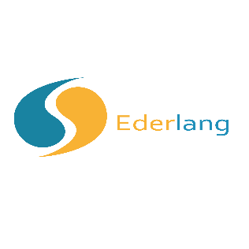

**Other professional experiences**

**Editor (Full-time)**

|  |  |  |
| --- | --- | --- |
| **Yaoundé** | **Cosmos Educational Press Ltd** | **2019-2020** |

* Knowing the curriculum used in nursery and primary schools;
* Receiving the works of different groups of nursery and primary textbook authors;
* Verifying that manuscripts/typescripts are in accordance with the curricula;
* Editing manuscripts/typescripts;
* Organising seminars and harmonising work with different groups.

**Journalist and Translator (Part-time)**

|  |  |  |
| --- | --- | --- |
| **Yaoundé** | ***Hommes/Femmes d’Afrique Magazine*** | **2016-2017** |

* + Interviewing, gathering and editing information;
  + Covering local, regional and international events;
  + Transcribing audio texts.

**Head of department and French langage Teacher (Full-time)**

|  |  |  |
| --- | --- | --- |
| **Yaoundé** | **Gerlinder Educative Center** | **2014-2015** |

* + Convening and chairing staff meetings in the department of French;
  + Designing teaching aids and assisting colleagues of the department;
  + Supervising and evaluating colleagues of the department.