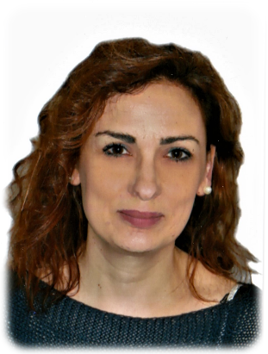
CV RESUME

Name: Marina Della Torre
Date and place of birth: Rome, 28.01.1973
Home address: 26, Vicolo del Cinque, 00153 Rome
e-mail: marinadellatorre.mdt@gmail.com
Telephone: +39 3394474338
Nationality: Italian
Native language: Italian
Status: Italy resident

Education and training
- Degree in Foreign Languages and Literatures (English and French) from La Sapienza University of Rome
- Advanced Degree in Technical and Scientific Translation from La Sapienza University of Rome
- Master’s degree in Medical Translation from IATI International Association Traduttori e Interpreti
- Further trainings: two webinars series on Translating Diagnostic Imaging (September and October 2018)
- years of translation experience: 3
- my specializations include: translation of Power Point slides, letters, literary texts, medical texts (reports, clinical charts, lecture notes)

Work Experience
- 2016-today Translator and assistant to Commercial Manager at Expertlab (innovative startup)
- 2001-2016 International Shipping Refund Department and Customer Services Coordinator at SDA Express Courier
- 2017 TWB member
- 2017 T4C member
- 2018 Proz.com
- 2017 IATI member
Technical skills and competences
Advanced Knowledge of Office Packages (Word, Excel, Power Point) Internet Explorer
Cat Tool: Déjà vu
I authorize the use of my personal data according to Legislative Decree n. 196/03
your faithfully
Marina Della Torre

