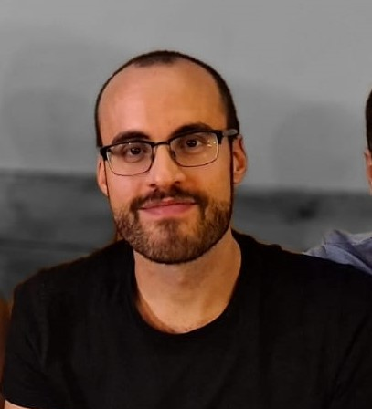
Filippo Simeone - Translator
E-mail: fil.simeone@gmail.com
Mobile Phone: +393331912672

LPs:
English (Any) --> Italian
Portuguese (Any) --> Italian
Rates:
EN --> IT (0.06 - 0.08€ per source word/ 12€ per hour)
PT (Eu/Br) --> IT (0.06 - 0.08€ per source word/ 12€ per hour)
Specialized in:
Tourism, literature, food, journalism, music, arts, history, culture
Work Experience
July 2020 - August 2020: Italian subtitles for Tyler Perry's Good Deeds, Daddy's Little Girls and Why Did I Get Married?
June 2020 - now: EN, PT > IT translations and Italian LQA, at Collegando S.r.l.
June 2020 - July 2020: Transcriber (en-UK and en-AU), Way2Global
February 2020: translation (EN/ES --> IT) and adaptation of subtitles for Tierra Calcinada, a Spanish documentary.
November 2019 - now: subtitles, ESO Department of Communication
September 2019 - June 2020: Media Project Manager Intern, Transperfect Barcelona
Main Tasks: Linguistic Final Eye and Final Ear in English, Portuguese and Italian and non-linguistic in most of the world's common languages; Quality Check for videos, subtitles, GFX; Contacting voice talents via email and phone; Script Formatting and Pronunciation Guides).
May 2019 - September 2019: Contributor and translator for Welcome to the Jungle, a website about music.
December 2017 - February 2018: professional translator, Italia Traduzioni.
June 2017 - now: subtitler and reviewer, TED conferences.
March 2017 - January 2018: translator and reviewer, Cafébabel.
February 2017 - June 2019: Collaboration with Sonia Netto Salomão, full professor at "La Sapienza" University.
Education

October 2018 - September 2019: Instituto Istrad, Specializing Master in Audiovisual Translation, Localisation, Subtitling and Dubbing. (10/10, SOBRESALIENTE).
February 2018 - March 2018: translation class at Oblique Studio, in Rome.
March 2017 - June 2017: translation class at La Matita Rossa.
October 2014 - January 2017: Master's Degree in Translation at "La Sapienza" University of Rome (110/110, summa cum laude).
October 2010 - November 2014: Bachelor's Degree in Linguistic and Cultural
Mediation Sciences at "Roma Tre" University (98/110).

Other
January 2018 - September 2019: Customer Care, at Welcome to the Jungle - Record Store (Rome)

