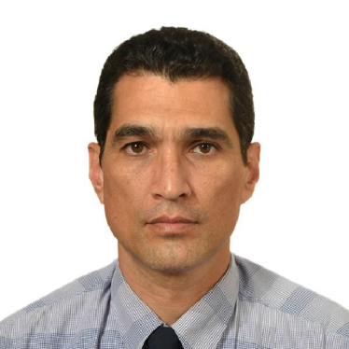
Juan J. Gil V.
Technical translator, English > Spanish
HSE Consultant

PROFILE
30+ years of experience in Engineering.
Electrical Engineer (major in Telecomm) with university-level studies in Financial Management, Marketing and Sales, General Management, Teaching and HSE, and teaching and lecturing experience has given me unique qualifications to provide reliable and accurate translations.

EXPERIEnce

Freelance EN>SP translator, 2014 to present.
Telecomm, IT: user guides, operation manuals, datasheets, PowerPoint presentations.
Safety, Engineering: operation and maintenance manuals, datasheets, user guides, product brochures, safety manuals and procedures.
Marketing: brochures, market research questionnaires, company and product descriptions.
Finance, Management: PowerPoint presentations, company brochures, training and educational material, web sites.
Medicine: Consent/Assent documents for a clinical trial of a device in a leading university of the USA.

EDUCATION
Electrical Engineer, Universidad de Los Andes, Mérida, Venezuela, 1991.
LANGUAGE TRAINING
English, CEPET, Venezuela, 1994.
English, Universidad de Los Andes, Mérida, Venezuela, 1991.

PROZ PROFILE
http://www.proz.com/profile/2346587

FULL TECHNICAL RESUMÉ AVAILABLE AT
http://ve.linkedin.com/pub/juan-gil/3a/688/596
CONTACT
Email: prof.jgil@gmail.com
Phone: +58 414 3601129

