CURRICULUM VITAE OF HANNELORE SCHWADORF

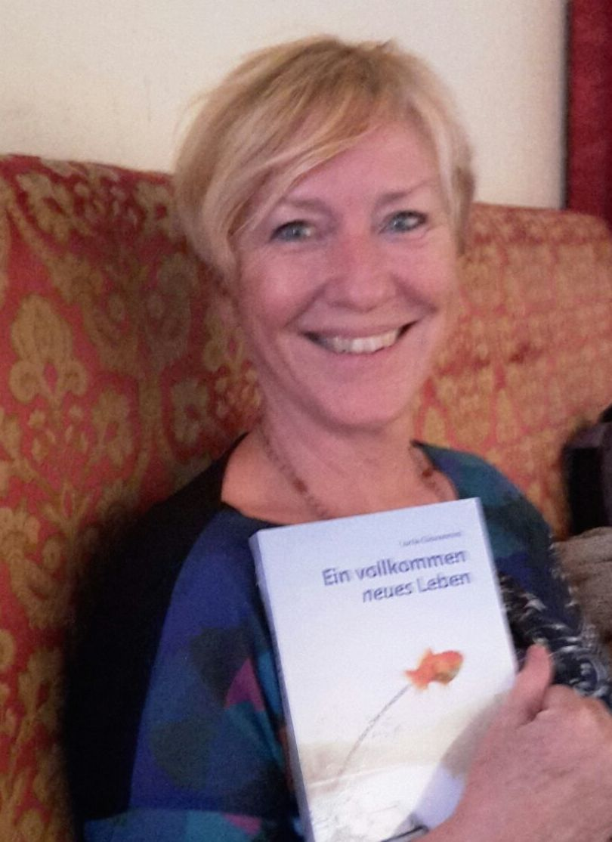

Personal informations

Name: Hannelore Karola Schwadorf
Adress: Via Brigidi 8, 47020 Longiano (FC)
Phone: 348 6299510
Mail: hannisan@libero.it

Nationality: German and Italian

Date of birth: 13/05/1956
Place of birth: Bonn (Germania)

Education and professional training

Dates: 1962-1975
High school degree from St. Adelheid-Gymnasium in Bonn (Germany)

Dates: 1976-1980
Degree course in Foreign Languages and Literature at the Faculty of Literature and Philosophy, University of Bologna - stopped on 4th year for serious health reasons.

Dates: 1987
Annual Course of "Congressional Organization" at the Language Center of Rimini

Dates: 1990 …
Activities as a publicist for the daily newspaper “Il Resto del Carlino” Membership in the National Association of Journalists

Main working experiences

Dates: 2018-today
Employer: Free lance
Job Type: Translation of many types of documents, from medical texts to
legal documents, from technical manuals to purchase and sale contracts, to degree theses in philosophy and literature.
PAGE 1/2
Dates: 2017
Employer: Babelcube
Kind of company: Translation mediation portal
Job type: Translation of the love romance: “Rhythm of Love” of
Serena Versari from Italian to German

Dates: 2014 …
Employer: Neue Erde
Kind of company: Publishing Company
Kind of employment: External collaboration, in 2016 publication of the German version of the bestseller "Tutta un’altra vita" written by Lucia Giovannini, translated by me.

Dates: 1997 - 2010
Employer: ROTEX Heating Systems s.r.l
Kind of company: German producer of heating systems
Kind of employment: Management and translation of the whole german documentation into italian language.

Personal skills

First language: German

Other languages: Italian – spoken and written: excellent
English – spoken and written: good
French – spoken and written: good

Interpersonal skills: Good interpersonal skills and good ability to mediate

between different mindsets (Italian - German).

Organization skills: More than ten years of experience in organization, orders office, administration, preparation of events, exhibitions, group tours.

Technical skills: Deep knowledge of the technical language in the
heating sector, large experience in the translation of technical manuals from German into Italian.
Special ability in literary translations.

Good knowledge of several PC programs:
Office, CMS Typo3, SAP, CMS Via Futura, Bäurer,

Aspirations:
I am available as a collaborator for translations of all types of texts from Italian, English, French into German.

PAGE 2/2

