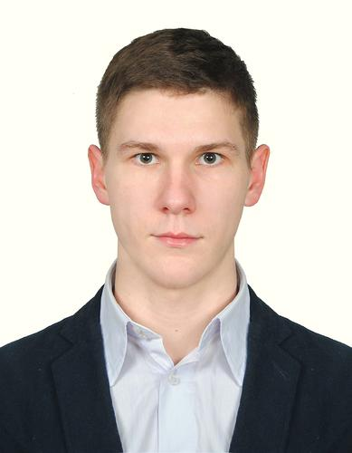
Igor Pavlov

Address: 6/8 Dekabristov Street, Korolev, Moscow Oblast, Russia, 141075

Email: pro-translation@inbox.ru

Skype: pro-translation

Mobile: +7-985-357-67-24

Language Pairs
Primary pair: English to Russian

Secondary pair: Russian to English

Work Experience
Freelancer-translator
Since December 2014 until now
I specialize in Software Localization - Android and iOS apps, videogames, websites and other related material.
Military Service
November 2013 – November 2014
After graduating the university I’ve been conscripted and served a year as a soldier in the Russian Air Force.
Bibliographer
Russian State Library, Research and Information Center on Culture and Art,
July 2013 — November 2013,
Moscow, http://www.rsl.ru
I was responsible for translating, editing and publishing articles on the website of the Library, as well as keeping the Russian/English glossary of department's internal search engine up to date.

Education
BA Linguistics
Moscow State University of Economics, Statistics and Informatics
Faculty of Linguistics and Intercultural Communication
Graduated in 2013, Moscow

Relevant Skills

Russian - Native speaker
English - Bilingual, translation skills
French - Pre-Intermediate level
German - Elementary level

I’m proficient with TRADOS’09 Studio, SmartCAT and Transit NTX. Other CAT-tools are also available if necessary.

