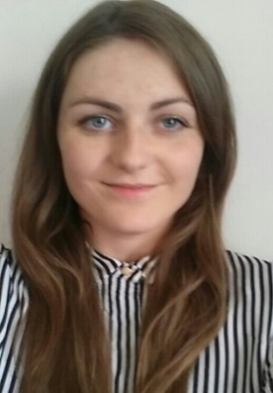
Eleanor McArthur
Mobile: 0033667939142
Email: elliemcarthur@gmail.com
Address: 86 Elm Hall Drive, Liverpool, L18 5JA
Date of birth: 25/08/1993
EDUCATION/ TRAINING

2012-2016 Master of Arts- Interpreting & Translating (English/ French/ Spanish) - Heriot Watt University, Edinburgh (Scotland)- First Class Honours
2014-2015 Erasmus: Madrid, Spain (6 months- Universidad Pontificia Comillas) & Lyon, France (6 months- Université Lyon Lumière 2).
2009- 2011 French Baccalaureate, specialisation in Music- Lycée Jules Michelet, Montauban (France) – Highest honours (“mention très bien”) (Overall average: 16.25/20)
LANGUAGES

English Native French Fluent (Bilingual)
Spanish Advanced German Beginner
PROFESSIONAL EXPERIENCE

November 2016- Present: Freelance translator, Mediateo, Barcelona (online)- Recent translation projects include 200 pages of hotel descriptions for a luxury travel website and a 50-page translation of a SAAS software comparison website.
June- September 2012, 2013, 2014, 2015, 2016: Kitchen assist & waitress, Château Dumas, Auty (France)
September 2013-June 2014: Bartender- The Cuckoo’s Nest, Edinburgh (UK)

VOLUNTEER EXPERIENCE

September 2014-2016: Translator for NGO- Child Finance & Youth International, online (EN>FR)
September 2014-2016: Translator for fashion magazine- TTT Magazine, online & 2 Paper editions (FR>EN)
March 2016: Liaison Interpreter- Scottish Chamber Orchestra, Glasgow (FR/EN)
December 2015: Interpreter for asylum seekers- Croix Rouge, St Antonin Noble Val (EN>FR)

ADDITIONAL SKILLS & INTERESTS

- Bilingual in English and French (British national brought up in France from the age of 9) & full professional proficiency in Spanish
- Passion for languages, international relations, current affairs, fashion, food and travel.

