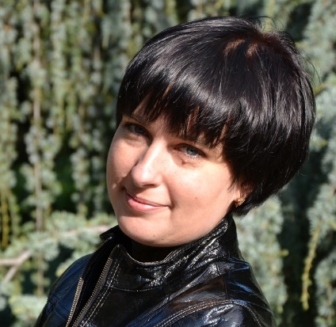
homenet2012@gmail.com
Skype – time2translate
Saint Petersburg, Russia
Mother tongue – Russian
+7 921 382 44 36

KAteryna zhylova
Summary |  | Knowledgeable translator with a strong command of English and French (read/write/speak). Have more than 10 years of experience with multinational clients. Having provided both written and oral translation and interpretation services between parties.
translation languages |  | English – Russian  French – Russian  Ukrainian - Russian
Specialization |  | IT and Communications  Technical Translation  Transport Logistics and Transport Mechanisms  Oil and Gas industry  Marketing, Tourism  Conference interpreting (consecutively, whispered)
skills |  | Interpreting, translation, terminology, work with translation software tools (Use SDL Trados 2014)  Video subtitling, auditing, subtitles translation, data collection and visualization  Able to work to tight deadlines  Highly skilled in Microsoft Office  Problem solving, research, social media, time management
experience |  | translator, interpreter  Freelance  May, 2005 - Present  •Translate a variety of written material such as correspondence, reports, legal documents, technical specifications and textbooks, maintaining the content, context and style of the original material to the greatest extent possible  •Revise and correct translated material  •Write articles in Russian, English, French for e-magazines and web-sites  interpreter, guide  Shore Companies  May, 2007 – November, 2013  •Local guide for different groups from around the world. Individual tours. Religious, historical, architectural and other thematic tours in English, French and Russian.  •Member of the World Federation of Tourist Guides Association, Cruise Guide and Interpreter Certificate  •Transport or escort individuals or groups on tours of cities, waterways and industrial and other establishments, describe points of interest, answer questions and supply information, provide historical and cultural facts related to the site
education |  | Master`s of Languages  Engligh, french, foreign literature  Crimean University of Social Sciences, Yalta  September, 2000 – May, 2005
personal skills |  | Detail oriented, Well organized  Fluent and logic, Deadline addicted  Accurate, Multitasking,  Excellent communication and social skills
certificates |  | Cruise guide, Tourism and Travel Services Management  World Federation of Tourists and Guides Association, Jan. 2012  IELTS Certificate, Dec. 2014

