PERSONAL DATA

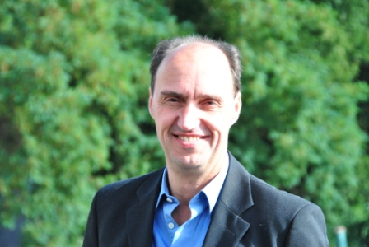

Frank van der Schuren

Peter Schreursweg 15

6081 NX Haelen

Tel.: (0475) 59 49 93

Mobile: 06-22518737

E-mail: solilocide@planet.nl

Born: The Netherlands, Kerkrade,

Date: 28 April 1961

Linkedin: http://www.linkedin.com/in/frankvanderschuren

Facebook: https://www.facebook.com/frank.vanderschuren

PROFESSIONAL EXPERIENCE

04/2014 till now (6 months): Linguistic Freelancer

Translating (EN-NL / NL-EN)

Proofreading

Copy-editing

Content optimization

Transcribing

Gespecialiseerd in vertalingen van commerciële teksten:

Websites

Product-omschrijvingen

Cursussen & handleidingen

07/2013 till 09/2013 (2 months): Bid en Tender Manager / Business Development Manager

Oad Business Travel B.V., Helmond

Business Development

Strategic advise opportunities, development 'new business'. .

Tender coordinator B2B (inclusive Touring car department, Sport & Event Travel, Group & Incentive Travel).

Support and advise Sales Managers for international sales, client implementations, bid- and tender processes etc.

12/2010 till 07/2013 (2 years, 9 months): Bid & Tender Manager

Oad Business Travel B.V., Helmond

Tender Management

Responsible for bid- and tender processes.

Tender coordinator B2B (inclusive Touring car department, Sport & Event Travel, Group & Incentive Travel).

Support and advise Sales Managers for international sales, client implementations, bid- and tender processes etc.

CORE COMPETENCIES

Organization competencies

Customer focused

Skilled

Performance focused

Collaborate

Job competencies

Communicate

Analytic ability

Planning and organizing

Environment focused

Creative innovation

EDUCATION AND QUALIFICATIONS

Experience in relation management, sales, project management, implementations, organization and planning

2015-now HOB Translator English

2011 GBTA Europe CTE Training, Fundamentals of Business Travel

2008 Account management training

2002 Training en Management “Management coaching”

1988-1995 Diplomas KLM Tariffs & Fares courses, all levels (I – IV)

1984 Diploma Professionalism Travel Trade (SEPR)

1979-1981: School for touristic education

Breda, Netherlands

H.A.V.O. (School for higher general secondary education)

Helmond, Netherlands

INTERESTS AND ADDITIONAL INFORMATION

Interests and hobbies: Dogs (Canine instructor, organizer information lectures, mentoring internships), literature, art & design, wines, travel, sports.

Married

2 daughters

