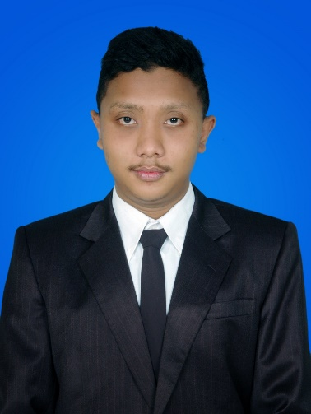
CURRICULUM VITAE
- Name : Andrew Susilo Burhannudin
- Place & Date of Birth : Malang, November 9, 1994
- Home address : Jl. Sulfat Agung 8 /45
- Telephone Number : +62-81937970410
- Sex : Male
- Marital Status : Single
- Religion : Islam
- Nationality : Indonesian
- Hobby : IT, football, and translating subtitle
- Background of Study :
  - Graduated from Elementary School Purwantoro 5 Malang in 2006
  - Graduated from Junior High School 11 Malang in 2009
  - Graduated from Vocational High School 6 Malang in 2012
  - Graduated from English Translation Program – Vocational Program of Universitas Brawijaya in 2015
- Courses :
  - Computer Training (2012 - 2013)
  - English Course (2010 – 2011)
- Job Trainings :
  - Computer Engineering and Networking staff at Villadata Informatika (2010 – 2011)
  - Translator staff at Vocational High School 2 Malang (2014 – 2015)
- Working Experiences :
  - –
- Other Activities :
  - Member of English Translation Student Association (ETSA) at Vocational Program of Universitas Brawijaya as Event Organizer (2013 - 2014)
  - Member of English Learning Club (ELC) at Vocational Program of Universitas Brawijaya as staff of Human Resource Development division (2013 - 2014 )

