English | हिन्दी | ગુજરાતી | ਪੰਜਾਬੀ | भोजपुरी | मगही | बज्जिका
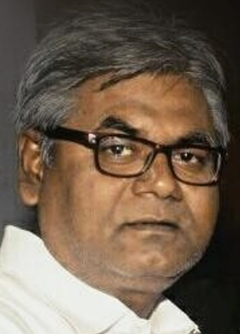
Anil K Gupta
Native Hindi Translator
https://www.proz.com/profile/2065616

Language is my passion. My fascination especially for any regional and tribal languages and dialects, has always given me the opportunity to study not only those languages and dialects, but the civilization and culture of those linguistic regions and societies as well. Over the past decade, I have had the privilege of participating in linguistic research with colleagues and scholars to save regional and tribal languages, including Angika, Sargujia, Santhali, Nagpuriya, and Vasavi.

In a translation task, I aim to convey all the meanings and expressions of the source language into the target language. Different glossaries, both domain-specific and client-specific, are always important to me. When I accept an assignment, I am aiming to deliver the desired results on time. I am readily available for inquiries, corrections, and modifications after delivery of an assignment.

Contacts
E-mail: anilgupta2762@gmail.com |  |  | Skype:  live:anilgupta2762 |  |  | Mobile/ WhatsApp:  +91 94704 58017
Language Proficiency
English | Hindi | Gujarati |  | Punjabi | Bhojpuri |  | Magahi | Bajjika
03  Professional | 05  Native | 04  Full Professional |  | 04  Full Professional | 05  Semi native |  | 05  Semi native | 05  Semi native
Jobs Acceptable
Translation, Transcreation, Transliteration, Creative Writing, Content Writing,
Transcription, Subtitling, Editing, Proofreading, MTP Editing, Reviewing,
LQA, Full language validation, Glossary creation, Language research
Working Tools
Trados, MemoQ (experienced, but the tools are not owned, only shared by some agencies)
MemoQ Web, Memsource, Wordfast Anywhere, SmartCAT, OmegaT, CafeTran Expresso, Prabandhak, MS Word, Excel, Power Point, Publisher, Google Docs, Google Spreadsheet, Page Maker, QuarkXpress
Domains of Expertise
Medical, Legal, Education, Banking & Insurance, Casino Games, Cricket, News & Media.
Other Domains worked for
Pharmaceutical, IT, Economics, Agriculture, Engineering, Energy, Market, Automobile, Transport, Tourism, Telecom, Retail Marketing, Development, Alternative Development, Alternative Energy, Social Sciences, Film, Television, Art, Culture, Literature, Indian Music, and more…
Educational Qualification
Graduation from BRA Bihar University, Muzaffarpur, India in Hindi and Political Science.
Working Experience: 30+ Years, Background: Journalism, creative writing and poetry writing
Worked as Media Consultant to Sh. Nitish Kumar, CM, Bihar.
I began my career as an editor of a fortnightly newspaper, and then went on to hold senior editorial positions with various local and national newspapers, including Dainik Jagran, Dainik Bhaskar, Rajasthan Patrika.
Address: Sambal, Near Zenith Petrol Pump, Gunnipur, Hajipur Road, Muzaffarpur 842002, Bihar, India

