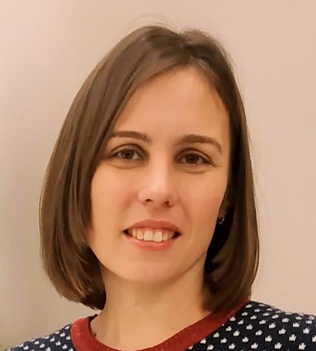
Nadezhda Derkach
EN>RU IT, Marketing, and Legal Translator

Phone | +380504010646, +380964123904
Viber, WhatsUp | +380504010646
Email | Nadiya-derkach@outlook.com
Skype, Whatsapp: | Nadiya_Olex
Current Job | Freelance translator and interpreter

PERSONAL SUMMARY

- I am a multi-skilled, reliable and creative translator in English-Russian language pair.
- My fields of expertise include blog posts, UI and UX texts, marketing texts, materials on social and political life, international organizations, tourism, legal and business documents, etc.
- CAT tools: Trados Studio 2017, MemoQ 2015, TStream, and virtually any CAT-tool provided by the client, as needed.
- Native languages: Russian, Ukrainian
- Proficiency in English: C2 (EF SET Certificate)
- I welcome any feedback and always act on it. Communication with my clients is most important to me.
- I learn quickly, easily absorb new ideas, efficiently adapt to new circumstances, and maintain timely communication.
- I am available on short notice, able to keep tight deadlines, efficient and reliable, result-oriented and flexible.

WORK EXPERIENCE

Freelance Translator – Self Employed
2014 – Present
Translating business, legal, medical, personal and other documents, articles on social and political life, tourism, and other topics from English to Russian and Ukrainian, proofreading, transcribing.
Currently working with Ukrainian and international translation companies:
- UI elements, messages UX texts, and marketing materials for an automotive project — about 100,000 words translated (for about 3 years).
- Marketing texts and blog posts for Snapchat website — about 50,000 words translated or edited.
- Descriptions of hotels, holiday destinations in Turkey — about 50,000 words translated or edited.
- Translations of restaurant menus, food products — about 30,000 words translated or edited.
- Texts for EU resources on social and political life — about 50,000 words translated or edited.
- Translation of business documents, surveys, user manuals — about 200 000 words translated (Synergium UAB and Ukrainian LSPs).
- Contracts, agreements, company policies, powers of attorney — about 200,000 words translated or edited (mainly for Ukrainian LSPs).

Interpreter
TheBigWord
2018–2020
Project job related to the international military training program, interpreting for individuals and groups of people from/to English/Ukrainian in day-to day situations and in the classroom. Participation in a multinational educational project.

Interpreter-Assistant to an LTO Team

OSCE ODIHR

2019–2020

Providing assistance, office managing, translation, and interpretation services to a team of Long-Term Observers from OSCE/ODIHR invited to Poltava Region for the presidential elections of 2019. Arranging meetings, booking hotels, hiring employees. Providing consecutive interpretation at the meetings with officials, representatives of political parties and NGOs in Poltava and nearby district centres. Providing translation and summaries of local news and social media monitoring.

Secretary-Translator
IRD Engineering
2013–2014
Project job, interpreting for individuals and groups of people from/to English/Ukrainian/Russian in day-to day situations and during small meetings. Assistance to people from abroad in communication with their Ukrainian colleagues and some Ukrainian institutions.
Translating outgoing and incoming letters related to road construction.
Interpreting during small meetings and personal conversations, making minutes of meetings.

ACADEMIC QUALIFICATIONS

English Philology, translations

V. N. Karazin Kharkiv National University 2017–2020

Bachelor of Philology

Education, MD

Poltava National Pedagogical University 2005–2010

Teacher of English language and literature

Additional training
- Academic English Writing, Understanding IELTS (British Council).
- Grammar and Punctuation, University of California, Irvine - in-depth grammar studies (Coursera).
- Translation of Legal Documents – online course (Industry-Specific Translation School).
- Translation of Contracts – online course by AlliancePro Translation Company and School.
- Understanding the basics of contract law (EdX – Contract X).

Basics of Economic Translation (macro data, exchange market, commodity market, financial reporting, technical analysis) by Alliance Pro Industry-Specific Translation School.

REFERENCES – Available on request

