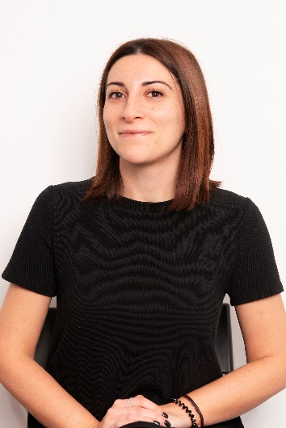
NATALINA DELL’OLIO
Freelance translator, post-editor and proofreader from German and English specialised in legal and marketing fields
Language teacher and tutor

CONTACTS
Tel.: +39 347 6924035
Skype: Natalina Dell’Olio
E-mail: delloliotranslation@gmail.com
LinkedIn: https://www.linkedin.com/in/natalina-dell-olio-a48106121/

WORKING EXPERIENCE________________
May 2017- January 2019: in-house proofreader at Arkadia Translations S.r.l., a Milan-based translation agency serving the legal, financial and international communication sectors:
- Proofreading and QA of texts in the legal, financial and marketing field from German and English into Italian (and vice-versa) before the final delivery to the client.
- Creation, management and updating of term bases and translation memories through different translation platforms and CAT tools such as SLD Trados Studio 2017, Memsource and MemoQ.
- Coordination of translators’ teams in case of big translation projects in support of project managers (text analysis, term extraction, creation of term bases and provision of stylistic guidelines, formatting and layout).

August 2016- April 2017: personal tutor at Wall Street English, Milan offices:
- Reception and administrative tasks.
- Support and tutoring of students during their educational path.
- Customer-care and follow-up activities, monitoring of the qualitative and quantitative performance of the centre

aimed at the maximization of the student satisfaction.
January 2014-today: freelance translator, editor and proofreader from German and English into Italian specialized in the legal, marketing and financial fields for several private clients and translation agencies.

EDUCATION_________________________
2013-2015: Master’s degree in Specialised Translation at the University of Bari “Aldo Moro” (languages of study: English and German).

2009-2013: Bachelor’s degree in Foreign Languages and Literatures at the University of Bari (languages of work: German, Russian and English).

EXPERIENCES ABROAD________________
March 2016-August 2016: Business and credit support administrator at Ford Credit Europe, Manchester:
- Customer support by phone and via e-mail in compliance with the Data protection legislation.
- Preparation, management and updating of customer records and reports on a daily and monthly basis.
- Translation of contracts and agreements and other corporate

documents from English into Italian.
January 2015-February 2015: Internship as librarian assistant at the Landesbibliothek of the University of Bonn (Rheinische Friedrich-Wilhelms-Universität).

September 2014-February 2015: Six months Erasmus at the University of Bonn (Rheinische Friedrich-Wilhelms-Universität Bonn).

March 2013-September 2013: Aupair for a German family living in Fulda.

POSTGRADUATE TRAINING____________
September 2018: training course “Legal translation from German into Italian” (“Laboratorio di traduzione giuridica dal tedesco all’italiano”), held in Pisa and organised by STL Formazione.
June 2018: online training course “Insolvency proceedings” (“Le procedure concorsuali”), organised by AGT Traduzioni.
April 2018: online training course “Financial contracts and agreements” (“Contrattualistica finanziaria”),organized by AGT Traduzioni.
February 2018: online training course “Civil proceedings” (“Gli atti processuali civili”), organised by AGT Traduzioni.
December 2017: training course “Post-editing and machine translation” (“Laboratorio post-editing per la traduzione automatica: istruzioni per l’uso”) held in Bologna and organised by STL Formazione.
October 2017: training course held at Arkadia Translations “Translating financial statements” (“La traduzione dei bilanci”).
October 2017: online training course “Contracts and corporate documents” (“Percorso di perfezionamento: Contrattualistica e Documenti Societari”), organised by AGT Traduzioni.
November 2017: online training course “Fundamentals of corporate law” (“Elementi di diritto societario (comparato)- 3 moduli”) organised by STL Formazione.

LANGUAGES________________________
Italian: mother tongue
English: IELTS, fluent, full professional proficiency
German: TELC, fluent, full professional proficiency

SPECIALISATIONS AND SERVICES PROVIDED Translation, proofreading and post-editing in the following fields:
- Legal: contracts and agreements, corporate documents (minutes, by-laws and memorandum of association), certificates and records of the chamber of commerce, policies and corporate regulations.
- Marketing: product descriptions, e-commerce, brochures and marketing documents, press releases for the fashion, design and finance industries.
- Economy and finance: market research and analysis.

COMPUTER SKILLS AND CAT TOOLS_______
Microsoft Office: advanced
Trados Studio 2017: advanced
MemoQ: advanced
Memsource: advanced
Matecat, Smartcat: intermediate
Operating system: Microsoft Windows 10

HOBBIES___________________________
Reading, travelling
Sports: Pilates e volleyball

