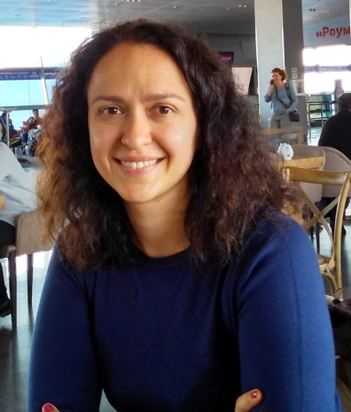
ELENA SHTRONDA
Freelance Translator

PERSONAL DATA
Date of birth: January, 1, 1981
Place of residence: Vyshneve, Ukraine
E-mail: e.shtronda@gmail.com
Skype: elena.shtronda
Mobile phone: +380 67 536 63 21

SERVICES PROVIDED
Translation, editing and proofreading of documents of any complexity
Language pairs:
- English – Russian/Ukrainian and vice versa
- Spanish – Russian/Ukrainian and vice versa
- Russian – Ukrainian and vice versa
Areas of specialization:
- Medicine (instructions for use and test reports for drugs and medical devices, surveys, summary discharges, analysis, conclusions of experts, certificates, references, etc.)
- Technical documentation (instructions for use, test reports, etc.)
- Automotive documentation (user guides, service books, maintenance manuals, etc.)
- Localization of software and help articles
- Translation of periodic printed socio-political publications
- Education (academic transcripts, diplomas, certificates, etc.)
- Tourism and real estate (descriptions of hotels, villas, residential complexes)
- Advertising and marketing (presentations, reviews, product descriptions, commercial offers, etc.)
- Finance and business (contracts, agreements, correspondence, etc.)
- Personal documents (certificates, references, CVs, etc.)
KNOWLEDGE AND SKILLS
Languages:
- Ukrainian — native
- Russian — native
- English — fluent
- Spanish — upper intermediate
- Chinese — basic
- Italian — basic
Software:
- MS Office (Word, Excel, Power Point, Outlook)
- SDL Trados Studio
- MemoQ
- Across
- XTM
- Verifika
- Xbench
Sales Manager skills (market analysis and sales plans, search and support of advertisers, negotiations, presentations, media-plans, accounting documentation, business correspondence)
WORK EXPERIENCE
February 2015 – present | Freelance Translator
August 2003 – February 2015 | Edipresse Ukraine LLC — Receptionist / Traffic Manager of Advertising Sales Department / Advertising Sales Manager / Senior Advertising Sales Manager, Translator (English — Russian/Ukrainian)
EDUCATION
1998–2003 | Kyiv National Linguistic University, qualification — Philology (Chinese and English languages)
July–August 2015 | English translation course, TRIS Translation and Interpreting Center
February 2015 | Course of lectures “Introduction to Tourism”, POEKHALI S NAMI Travel Agencies
1995–1998 | Linguist Language School, Bila Tserkva, English language
PERSONAL QUALITIES
Active life position, purposefulness, creative approach to work, self-organization, diligence, punctuality, fast learner

HOBBIES

Foreign languages, travelling, snowboarding, dances, cinema

