Magali Bouyer Frias-Translator Barcelona

Language combination Spanish>French + English>French
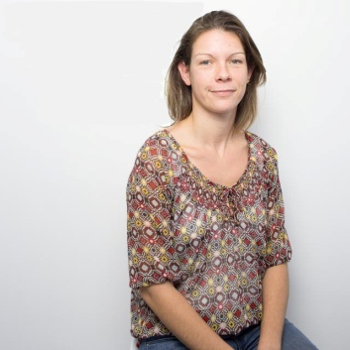

Specialized in Tourism and travel, hospitality, website translation
Born 26/02/1980 in France
E mail: mbouyer2000@yahoo.fr Tel: +34 692898910

Educational background:
1999. Degree in Tourism: BTS Tourisme. Lycée Cordouan, Royan, France

Languages:

French: native language
Spanish: fluent, speaking, reading, writing. Daily personal and professional use
English: fluent, speaking, reading, writing. Daily personal and professional use

Professional experience:
● From January 2015: touristic texts translation for K.M. Alarabi, SL agency http://www.kmalarabi.com (touristic information websites, events, restaurants, hotels…)
● From March 2015: touristic texts translation for Carolina López Traducciones agency http://carolinalopeztraducciones.com/ (touristic information websites, hotels, articles…)
● From 2007: Customer service agent- Only-apartments, S.A. (Short term rentals online agency)
-Customer service in English, Spanish, French
-French translations for mailing and website information and contents
● Previously, I have been working in tourism since 2000 in several countries and jobs (guide, tour operator representative, tour company receptionist, hotel concierge…)

Other information:

LinkedIn profile: https://www.linkedin.com/in/magalibouyer

Translation software: SDL Trados Studio

Member of Asetrad (Asociación Española de Traductores, Correctores e Intérpretes: Spanish Association of Translators, Correctors and Interpreters)
Translation, revision
Stay in other country: Dominican Republic residence from 2000 to 2006, Spain residence since 2007
Minimum rate for general texts: 0.05€/word
Accepted payments: bank transfer, PayPal

