Curriculum vitae
Freelance translator
Name | SHKRABO Olga |  | 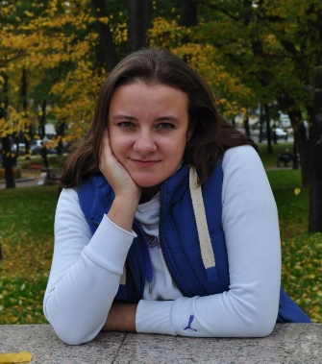
Date of Birth | 22.04.1985
Phone | +375-44-717-52-60  +375-29-758-97-12
E-mail | volha.shkrabo@gmail.com
Web | http://www.proz.com/translator/1954922
Languages | Source | Native
 | English | Russian/Belarusian
 | German | Russian/Belarusian
 | SPECIALIZATION FIELDS
 | Pharmaceuticals, Pharmacology, Medicine, Medical Equipment
 | EDUCATION
2002-2007 | Belorussian State University, Faculty of International Relations, specialization: modern foreign languages (English, German)
2009-2013 | Belorussian State University, Philological faculty, postgraduate education,  specialization: foreign literature (English literature of the XVIIth century)
2015 | Minsk State Linguistic University, Faculty of Advanced Training and Staff Retraining, educational program “Practice of Interpretation and Translation” (English)
2015 | Course of spoken language with native speakers “English as a Second Language”
2017 | Webinars “Translation in Clinical Studies” (by Ekaterina Chashnikova)
2018 | “Introduction to medicine: basic medical training for translators”
 | WORK EXPERIENCE
2007 – 2018 | Department of Translation Theory, Faculty of Social and Cultural Communications, Belorussian State University  lecturer
2008 | BelElectronComplect Co. Ltd.  translator of technical documentation
2007 – to the present day | freelance translator
 | Volunteer activity
2015 – to the present day | “Translators without Borders”  volunteer translator

