Maged Nabieh Abd El- Moneim Aly. 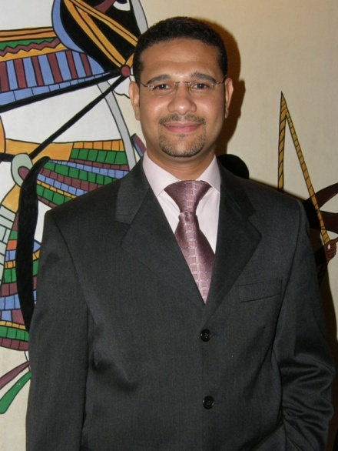
18, Dr, Ahmed El Rashiedy St ,
Al Khalafawi – Al Sahel – Cairo - Egypt
EmaiL: info@udlz.de
Website:www.udlz.de
Mobile phone: (+201224115591)
Tel: (+202) 24323113.

Birth Date : 7/ 6 / 1978.
Birth Place : Cairo.
Social Status : Married.
Nationality : Egyptian.
Military Service : Exempted.
Qualification

- School : (G.S.C) Graduated from a language School,
- 1st foreign language English.
- University Education : Graduated from "Tour Guiding Department." of the Faculty,
of Arts, Ain Shams University, Cairo, Egypt. 1999 – 2000.
- Language skills :
German: Excellent (Written &Spoken).
English: Excellent (Written & Spoken).
Arabic: Mother tongue with a good ability for Creative Writing and Original Thinking and expression.
- Computer skills :
Microsoft basic applications: Windows ,Word, Excel, Power Point & Internet.
Typing speed: Very Good (English and Arabic).

- Special Courses :

- -Finished the German Language Levels at 'Goethe Language institute’ Cairo. (21 levels).

- -Finished a specialized course in translation (English-Arabic/Arabic-English) from Ain shams university-Cairo-Egypt.

- -Forgery and Falsification training course at Ministry of Interior Affairs – Egypt.

6) Personal Qualifications:

-Hard Worker with an ability to work under pressure to meet deadlines.

-Good negotiation and Presentation Skills.

-Ability to work independently to perform delegated tasks with minimum Supervision.

7) Membership In Organizations and Professional Associations

Member of "The Egyptian Translators and Linguists Association (ETLA) Registered Association, " Membership No. # 220.

8) Previous Experience :

- Working Currently as "a Free lancer Legal Translator/Interpreter"
(German-Arabic /Arabic-German language) (Sept 2008 - Till date).

Job description:
A- Translating, Proofreading for different kinds of Legal documents such as Contracts, Legal judgments, Power of attorneys, Criminal records, Licenses, Legal reports and Correspondence.

B-All types of Certificates (i.e. Birth certificates, Marriage certificates, Taxation and customs.

C-Interpreting, Attending Conferences and Meeting, Interpreting over the phone etc.

--------------------------------------------------------------------

2)Worked for “Egypt yellow pages Ltd.-publication,” As Translator and Copywriter, Proofreader at the publishing Dept. (Jan/2004 Till May/2008).

Job description:

A)-Handling translations from English to Arabic and vice versa for Ads of the famous business directory and all the related, including different kinds of company documents.

B)- Handling the directory Ads: as well as online Ads for the web site with Arabic copy, the process which involves as well proofreading, checking, literally and linguistically.

C)-Creating Slogans, Branding unites, Signature lines if needed for a wide range of Products, which involves Concept Translation if originated from English as well as Arabic Original Creative Thinking.

D)-Translating and preparing Press Releases and Write-ups and Periodical Articles.

3) Worked for “TNT World Wide Office At the Visa Section U.S Embassy Cairo”.
(Nov 2000 - Nov 2003)

Job description:

A) Dealing with Customers Providing Them with necessary Information concerning different kinds of Visas & Delivery tariffs.

B) Dealing with Embassy's employees & Consuls providing them with Aid & Assistance related to Delivery and courier Services.

C) Translating different kinds of Documents including Correspondence between the Us Embassy Cairo and the company TNT world wide.

P.S;Documents Furnished upon request.

