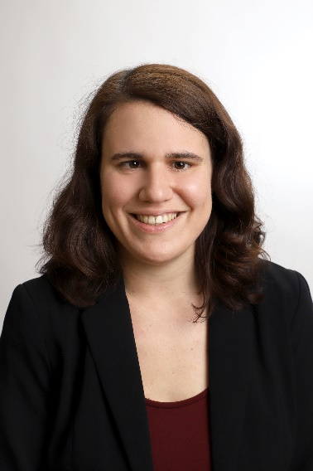
Nadine Schmid, BA
21/05/1992
Schießstattgasse 8A/8
8010 Graz (Austria)
Telephone: +43 660 7088637
Email: nadineschmid@aon.at

Education
10/2017 – present Master’s degree in Conference Interpreting (English, Spanish) – University of Graz (graduating in December 2020)
Working languages: A: German, B: Spanish, C: English; focus on consecutive and simultaneous interpreting in conference settings; additionally, courses on public service and liaison interpreting as well as an introduction to speech-to-text interpreting for the deaf and hard of hearing
Additional translation certificates: English, Spanish (areas: legal translation, public services, science and technology)

11/2015 – 06/2017 Máster en Traducción Creativa y Humanística – University of Valencia
Master’s degree mainly centered on literary and audiovisual translation; subtitling both for a general audience as well as for the deaf and hard of hearing, audiodescription for the blind and visually impaired

02/2015 – 12/2015 Grado en Estudios Hispánicos – University of Valencia
Courses from the Bachelor’s degree in Spanish Philology, including Spanish and Latin American literature, theater, phonetics and morphology

10/2010 – 02/2015 Bachelor’s degree in Transcultural Communication (English, Spanish) – University of Graz
Topic of my Bachelor’s thesis: „The use of international English on university websites“
Additionally, Spanish and French courses at the Department of Romance Studies

09/2012 – 06/2013 Erasmus year at the University of Valencia

09/2006 – 06/2010 Oberstufenrealgymnasium der Franziskanerinnen Vöcklabruck (general qualification for university entrance)

Work experience
01/2017 – present Translations for various agencies (BigTranslation, OneHourTranslation, LionBridge); interpreting jobs (at the conference „Resources and tools for T&I Education“ on 20/09/2019, interpreting Latin American stories for the project „Arte sin fronteras – arts without borders“ (11/2018), at the final ETHOS conference held on 19/11/2019 in the Styrian Broadcast Studio)

04/2017 – 06/2017 Internship at El Temps, a weekly magazine written in Catalan (translation of articles published in the German magazine Der Spiegel into Catalan)

06/2016 – 12/2016 Audiodescription reviser and translator at Feedback Cultural, a Valencian start-up that aims to increase accessibility in Valencian museums for the blind and visually impaired

03/2015 – 07/2016 Teacher for German as a foreign language in courses organized by the Servei de Política Lingüística (language policy service) at the University of Valencia

06/2014 – present Voluntary translations for NGOs (Solidarity Africa Practical Projects)
Other skills and achievements
Languages:
German native speaker
Spanish: C1; DELE: Certificate for Spanish as a foreign language
English: C1
French: B2
Catalan/Valencian: B2

Computer skills:
Advanced Microsoft Office user, basic skills in using computer-assisted translation tools (SDL Trados, Fluency Now), subtitling software (Subtitle Workshop), basic skills in HTML, audio editing software (GoldWave, Audacity)

Further qualifications:
Courses offered by UNIVERSITAS Austria (Austrian translators and interpreters association): Creating translation quotes (04/2020), German orthography (04/2020), Marketing for translators (09/2018)
09/2016 – 12/2016 Certificate: „Corrección profesional de textos“ (proofreading Spanish texts) – Cálamo y Cran

Graz, 15.07.2020

