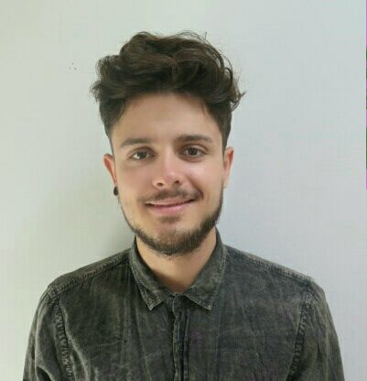
David Araque Borrás

Media & Literature Specialized Translator
Interpreter

Academic Background
2010 - 2015 Translation & interpreting Degree – Jaume I University
- Media Translation Specialization
- Literary Translation Specialization
- Interpreting Specialization

language is, nunc. Mauriseqetnequeatsemvenenatis skills
Catalan/Valencian Mother Tongue
Spanish Mother Tongue
English High Comprehension Level, High Writing and Speech Levels
German High Comprehension Level, Medium Writing and Speech Levels

additional

background
C2 certificate of english c2 – Embassy CES, Los Angeles
Cat tools course for translators – Jaume I University
Project manager course – AFIM Foundation

work

Experience
Freelance translator (technical translations, law translations, media translations, literary translations)
International alliance of inhabitants (jornalistic translations) – Translator & Proofreader (volunteer)
Global Voices Online (law translations) – Translator (Volunteer)
SDI Media Iberia (Internship) – Quality Control & Media Translation

additional

information

Software: SDL Trados Studio, Omega-T, Subtitle Workshop, Aegisub, Translator’s Workbench, Wordfast.
office software: Microsoft Office (Word, Powerpoint, etc.), OpenOffice.

