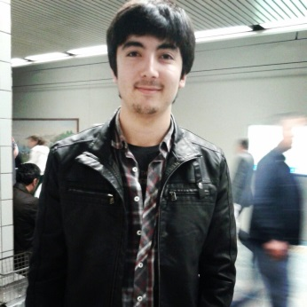
Murat Ertekin
About me
I am a Translation and Interpreting Studies student in Bosphorus University. I am this translation world because I feel free while doing translations. It doesn’t set me any boundries. I feel free to make some changes in writings, structures etc. As I am in this field voluntarily, I want to improve my skills and be one of the respected translator in the world. I know I am at the bottom of the ladder and that I have to work years to be that person, but it doesn’t scare me at all. I am a hardworking person and I get whatever I want. I am an ambitious person. I do everything to achieve my aims. Clearly saying, I will do everything that is wanted from me to be the best translator. I am very quick to learn new things. I have always been open to innovations. I am a curious person. I like searching something I don’t know. Meeting new people from different places, countries will broaden my viewpoint in the translation world. I know that a translator should know as much as possible. I always follow current issues and read as much as I can. As Peter Newmark says “A satisfactory translation is not always possible, but a good translator is never satisfied with it. It can usually be improved.” I see myself as that ‘good translator’ and always try for better.

Address: Bosphorus University, 1st Men’s Dorm Room No: 213 Bebek/Besiktas/Istanbul
Phone Number: 0536 622 68 15
E-mail : muratertekn@gmail.com / murat.ertekin@boun.edu.tr
Date of Birth : 09.10.1992
Birth Place : Burdur / Altınyayla
Gender : Male
Marital Status : Single
Educational Status : Licence
Educational Background :
2011 – Bosphorus University Translation and Interpreting Studies Department
2012 – Anadolu University School of Open University International Relations 2008 – 2011 Antalya Atatürk High School Foreign Language
2008 – 2000 Antalya Mobil Primary School
Languages : English (Advanced)
Spanish (Intermediate)
Experiences : Translations of TV series “Kabadayı” for 10 episodes – text translation from Turkish – English
Warner Bross contract translation from English to Turkish
Translations of contracts of construction companies from Turkish to English
Translation of history of the company “Abdi İbrahim” for a website.
Literary translations from Japanese Anthology (for a project in one of my courses) from Turkish to English
Translations of user manuals and technical texts.
Translations of text of a presentation lasting 245 min. From English to Turkish.
Computer Knowledge: Microsoft Office Word – Excel – Powerpoint (Advanced)
MemoQ (Advanced)
Xbench

