CURRICULUM VITAE GAIA RUPOLO
FREELANCE TRANSLATOR

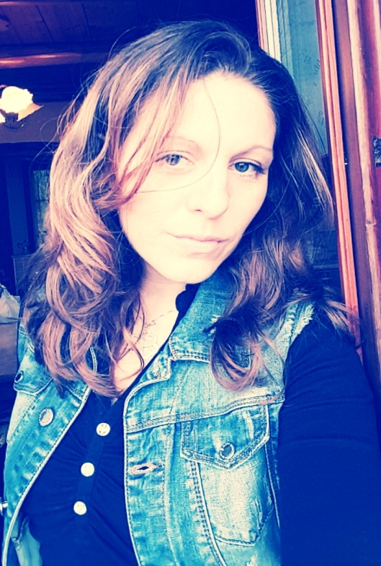
Gaia Rupolo
Address: via Cambiesso 2/B, 28816 Intragna (Verbania), Piedmont
Date of Birth: 1979, 23 June
Marital Status: married
Nationality: Italian
Cell - phone: +39 349/5906559
E-mail: gaiarupolo.traduzioni@gmail.com

CURRENT OCCUPATION
Freelance translator from English and German to Italian.
Proz.Com Certified PRO in German and English to Italian
TraduGuide Featured Member: https://www.traduguide.com/tr/44949.htm

SPECIALIZED SECTORS
Corporate Communication & Marketing, Business Management in the following fields:
- Cosmetics
- Food and Beverages
- Paper
- Tourism
- Multi-level Marketing
- Automotive (various business documents, code of conduct, regulations, submission of documents, ecc).
Legal (contracts)
Environment (renewable sources, waste management and disposal, waste recycling)
Editorial: I’m working with “Damiani Editore” Publishing House (Italy), “Il Cairo Editore” Publishing House (Italy), and HarperCollins Publishers (NY,U.S.A).

WORKING EXPERIENCE
- 04/1999 – 07/2004
Part-time sales officer (open-ended contract).
Sector: woman’ and childsware.
Company: United Colors of Benetton
Place of work: Shopping Centre “Auchan”, Rescaldina (MI)

- 08/2006 – 06/2011
Part-time sales officer (open-ended contract)
Sector: womansware.
Brand: “OLTRE”
Company: Miroglio S.p.A
Place of work: Shopping Centre “Le Isole”, Gravellona Toce and “Oltre” Store, via San Vittore, Verbania Intra (VB).

- 07/2011 up to today
Self-employed worker
Freelance Translator German – Italian, English – Italian

EDUCATION
- 09/1992 – 06/1997
Linguistic diploma, get by “Liceo Linguistico Europeo Enrico Fermi” in Castellanza (VA).
Languages: Latin, English and German.
Grade: 56/60

- 09/2001 – 06/2005
Degree in Foreign Languages and Literatures taken by the state university of Milan.
Grade: 92/110

PERSONAL SKILLS AND ABILITIES
As far as my profession is concerned: as a translator, besides a great passion for my work, I have a complete mastery of my mother language, that is not to be taken for granted; I think of having acquired a strict system of research and control of the translated texts; I’m able to guarantee an absolute respect for the delivery terms and conditions required by the clients.

The great experience I have made in the companies for which I’ve worked and in the workplaces has further enriched and increased my professional fund, giving me the possibility to strengthen my relational abilities.

Working as a freelance translator since 2011, I perfectly use data processing, I follow refresher courses and I have a technical service to assist me in my work.

DATA PROCESSING
HW/SW: PC System Core i7, Windows 10, Wi-Fi connection.
Office 2010, CAT: Dejà Vu (DVX3), TRADOS (SDL Trados Studio 2019 Freelance).
TO3000 for business management and invoincing.
Other specialistic utility software.

NOTE
About the English Language: developed through the years with parallel foreign language courses and in the working place. I got through the First Certificate in English in June 1995 at the British Institute in Milan. In my specialization fields I can translate from English to Italian without any difficulty, thanks to my stay in New York from 1999 to 2005. My translation works during my freelancer career witness what said before.

I’d like to work together with you, hope that my abilities and skills
meet your requirements.
I authorize the treatment of my personal data.

