Profile
Lara de nadai 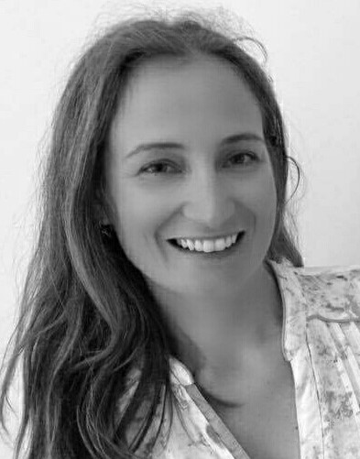
0485/ 825.141
laradenadai@hotmail.com

Av. Albert Jonnart, 34
1200 Brussels
Belgium

Born in Italy on 25 July 1973
Married - one child
Responsible, receptive, empathetic and kind

Experience

Sworn French <> Italian freelance translator
Freelance Italian teacher 2009 — present

Freelance translator in the following fields:

=> animation (production company Lanterna Magica, Piste Rouge)

=> advertising (e.g., Agence DDB and Marketing Power Rapp)

=> medical (e.g., medical reports for Saint Joseph Hospital and private customers)

=> legal (e.g., Société The Cotton Club, Brussels court, Federal Police, lawyers' offices and notarial deeds)

=> literary (Thomas Gunzig and Barbara Abel)

Member of the Belgian Chamber of Translators, Interpreters and Philologists — 2007-2009

CLL, Kraainem — 2006-2008
Italian teacher
Tutti Frutti school, St Gilles — 2006-2007
Italian teacher
Istituto Sacro Cuore, Trento, Italiy — 2003-2005
Extracurricular counsellor for groups of about fifty children each
Homework school

Stefanel S.p.A. store — 2000-2003
Responsible for selecting collections and participated in store management

Confezioni V.D., Treviso I Italie
Management of staff (30 people) and of production

Languages

Italian Mother tongue
French Excellent
English Good

Studies

Master's degree in foreign literature in French and English
at the University of Trento Faculty of foreign languages and literature 09.2000 - 08.2006

Main subjects/professional skills covered: pedagogy, linguistics, and teaching languages

Thesis: Henri Michaux: a traveller's and writer's experience in "Ecuador" and "A Barbarian in Asia"

Designer course of the European Social Fund, Venice

Diploma in design 09.1999 – 05.2000

Main subjects / professional skills covered: creation of a fashion collection

Istituto Riza de médecine olistique Milan

Diplôma for food and herbal medicine specialists 10.1998 - 06.2000

Liceo Classico "Eugenio Montale", San Donà, Italy

Maturità classica 09.1988 – 06.1993

Skills
MS Office

Leisure
Reading, horse-riding, travelling, theatre and cinema.

References
Upon request

