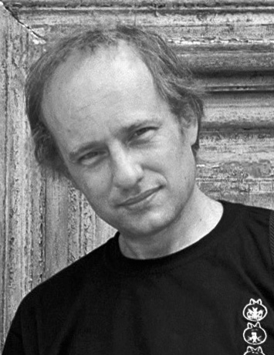 | Philippe Drevet  B6-203, Westwinds, Mazilwadoo, Salcete, Goa  Skype : drevetph  Email:drevetph@gmail.com  Phone.: +91-7517032401  Translation from English and Portuguese into French

PROFESSIONAL ACTIVITIES IN INDIA
Language Services Bureau (2017-2018)
Translation from English into French for Alfa Laval, Mahindra, Tata, Larsen Toubro, Suhana, etc. Technical documentation for pumps, separators, filtration, bikes, tractors etc. Food packagings (150,000 words)
Language Consultancy Service (2014-2017)
Translation from English into French for the site of the Ministry of External Affairs of India. Prime-Minister, President and Vice-President speeches, press statements, visa regulation, etc. (2,550,000 words)
Express International Translations (2013)
Translation from English into French for The Healthline. Health services of Ontario. (1,000,000 words)
Siddhartha(2013)
Translation from English into French for Office Support Site (140,000 words)
Embassy of Brazil in India (2007-2012)
Translation from English into Portuguese translation of IBSA and BRICS documents and Indian Certificates
IANS (Indo Asian News Service), New Delhi (2008-2012)
Translation from English into Portuguese of Noticias da India, newspaper published by the Embassy of India in Brazil (1,400,000 words)
UNICEF India, New Delhi (2008)
Transcription and translation from English into French of the movie Mapedir, Safe Road to Motherhood. Translation from English into French of Health Reports ans Curriculum Vitae (Chad’s Minister of Health).
Alliance Française, New Delhi (2007-2011)
Teaching intermediate and advanced levels (B1, B2, C1). Translations and proofreading from English into French of technical handbooks, magazines and certificates
Vidushi Academy, Bangalore (2011)
Translation from English into French of technical handbooks (Unified Metadata Software, Pulse Oximetry Sensor, Union Pump).
Translation from English into French of scientific papers (Polyacrylamide and Water Quality Effects on Infiltration in Sandy Loam Soils)

Paragon Media, Delhi (2007-2011)
Translation from English into Portuguese of market studies (Footwear, Ceramics, Precious Stones, Cosmetics-Toiletries, Tropical Fruit Juices)

PROFESSIONAL ACTIVITIES IN BRAZIL
Revista Brasileira de Ciências Sociais, Rio de Janeiro (2010-2013)
Translation from English into Portuguese of scientific papers and abstracts
Fundação Getulio Vargas, Rio de Janeiro (2009)
Translation from English into French translation of the movie Mulaqat, directed by Claudio Pinheiro
Alliance Française of Porto Alegre, Brazil (2002-2004)
French Teaching. Translation and proofreading fromPortuguese into French
Federal University of Rio Grande do Sul (2002-2004)
Translation from French into Portuguese of Directives européenne relative à l'importation du Soja et de la viande : (15,000 words).
Portuguese to French translation of La cuisine du sud du Brésil de Maria Eunice Maciel : (40,000 words) and L'image visible en tant qu'image invisible: un paradoxe de l'art dans l'espace public (20,000 words.
Translation from French into Portuguese and subtitling of Quartier Lacan de Emile Weiss and Moi, un noir de Jean Rouch
State Foundation for Environment Protection (FEPAM), Brazil
Photographic report and realisation of a multimedia CD Portraits and Landscapes for the FEPAM

PROFESSIONAL ACTIVITIES IN FRANCE
Centre de Recherche et de Restauration des Musées de France (Louvre), Paris
Conception and presentation of the specification report for 3D scanning of rock paintings in the Sahara desert. Photogrammetric and project management , 2005
Appui Image Laboratory, Paris,
Management of a digital photographic service – retouching, digitalization, batch treatment for Web site, (customers include Les parfums Givenchy, Christian Dior, Nouvelles Frontières, Club Méditerranée, Les Galeries Lafayette, Bazar de l’Hôtel de Ville, Printemps,FIFA), 1995-2000
Groupama, MSA
Report, studio and graphic works to illustrate magazines, project, exhibition, convention and annual report , 1986-1994
Studirec – Aries
Studio photographer and graphic works for the audiovisual production of business and cultural events — Coca-cola, Fondation Glace Gervais, Suchard, Benedicta, Aspro-Larochette, Sogaris. 1982-1984

EDUCATION
2005 : Graduation of Computer Sciences Engineering, Paul Cézanne University, France.
2000-2001: Portuguese Course - Federal University of Rio Grande do Sul, Porto Alegre, Brazil.
1986: Videomaker Assistant Training, FR3 TV Provence in the film « Le prix d’un homme ».
1985-1986: Video Training Course, Saint Charles University, Marseille, France.
1982: BTS (two-year technical degree) Photography, Louis Lumière School, Paris, France.
1980: DEUG (two-year university degree) in sciences, Aix-Marseille III University, France.

COMPUTER SKILLS
SDL Trados, Wordfast, MemoQ, Microsoft Office, Acrobat, PHP, XHTML, CSS, Regex

