Curriculum Vitae
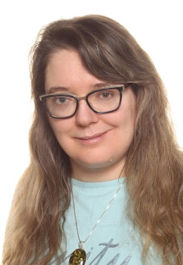
KAROLINA ANNA KOGUT
born on October 28, 1986 in Łódź
address:
ul. Bohaterów Września 10 m. 25, 98-200 Sieradz
e-mail: karkog1@poczta.onet.pl
tel.: 502687070

EDUCATION

2010 – 2012 Postgraduate Translation Studies at the University of Łódź
Łódź 90-522, ul. Wólczańska 90
English language
grade for the diploma project: very good with distinction

2005 – 2010 Institute of English Studies of the University of Łódź
Łódź 90-514, al. Kościuszki 65
Master of Arts in English philology, specialization: translation of literature
final grade: very good

2002 – 2005 Stefan Żeromski High School No. 2
Sieradz 98-200, ul. Żeromskiego 8
class with extended curriculum in humanities

PROFESSIONAL EXPERIENCE

2015 – currently own translation business under the name CARRIE TRANSLATIONS
Sieradz 98-200, ul. Bohaterów Września 10/25
job position: business owner, freelance translator of English
- translation of texts commissioned by the entities listed below (as a subcontractor), as well as for own clients (mostly business documentation and academic papers)

2013 – currently Centrum Lokalizacji C&M Sp. z o.o., from September 2015 operating as
Centrum Lokalizacji CM Sp. z o.o. sp. k.
Wrocław 51-609, ul. Chopina 18
job position: freelance translator of English (subcontractor)
scope of duties:
- translation of marketing, medical, technical and IT texts, including patient documentation, patents in genetics, molecular biology and new technologies, instruction manuals for specialist medical applications and devices used in the energy industry

2012 – 2016 MX Publishing
335 Princess Park Manor, London, N11 3GX, UK
job position: translator
scope of duties:
- translation of Sherlock Holmes-related literature
2010 – currently “Sens” Translation Agency
Łódź 91-363, ul. Jesionowa 36 m. 23
job position: freelance translator of English (subcontractor)
scope of duties:
- translation of technical and marketing texts, including instruction manuals and product descriptions for leading manufacturers of gardening and kitchen equipment, as well as texts for the purposes of international educational projects

LANGUAGES:

- English – fluent spoken and written
- Spanish – basics
- Latin – basics

SKILLS:

Computer skills: knowledge of Microsoft Office and CAT software (Trados Studio)

INTERESTS:

Gothic literature, fantasy films and literature, RPG, languages, Gothic architecture, new technologies, electronics

PERSONALITY CHARACTERISTICS:

diligence, patience, responsibility, reliability, focus on self-improvement, willingness to learn new skills

I hereby give consent for my personal data included in the job offer to be processed for the purposes of recruitment.

