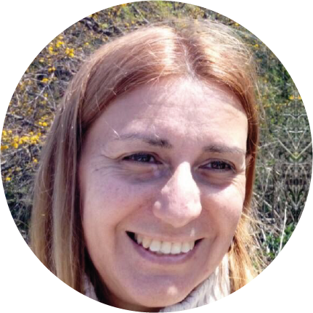 |  | Alicia susana villegas  English Spanish Sworn Translator from Argentina  Birdwatcher and photographer of nature
profile  Professional English Spanish Translator and Teacher with more than 25 years of experience in science, chess and areas of education such as mathematics, physics, geography, history, literature, language, psychology, pedagogy, law and biology.  Experience in translation of books, multinational agreements and personal documents.  Excellent communicative and writing skills.  Love for birdwatching, photography of nature, and nature itself, ecology and literature.  Contact  Mobile Phone and WhatsApp:  +54 9 11 6828 2391  E-mail:  aliciasvillegas@yahoo.com.ar  Instagram: villegasaliciasusana  Skills  - Critical Thinking and Problem Solving  - Interpersonal Skills  - Communication Skills  - Flexibility and Adaptability  - Ability to multitask  - Good Humour  - Rapid adaptation to changes  - Enthusiastic attitude |  | Education  University of Buenos Aires, Argentina:  - Degree in English Spanish Sworn Translation and Interpretation. (Average Marks: 8+)  - Postgraduate Course in Advanced English Language.  - Postgraduate Course in Foreign Trade.  - Postgraduate Course in Interpretation.  - School of Law, 3 years. (Average marks: 8+)  - School of Natural Sciences, Mathematics and Physics, 1 year.  University of La Punta, San Luis, Argentina:  - Diploma in Solar and Wind Energy. (Average Marks: 8+)  - Teaching Training College: I. E. S. Lenguas Vivas, Buenos Aires, 3 years.  - Scholastic Chess Teacher, Diploma awarded by Argentine National Ministry of Education.  - Presently I am studying “Animal Behaviour” at Argentine School of Naturalists.  - Birdwatching, 19 years.  - Photography of Nature, 1 year.  - Gardening, 20 years.  - Chess, 40 years.  JOB EXPERIENCE  Translations of the following books:  - Russian Silhouettes.  - Caissita y el mágico mundo del ajedrez.  - Memorias de un peón de ajedrez.  - Ajedrez con Panno.  - Expert Heads Up No Límit Hold' Em. Volumen 1.  - Expert Heads Up No Limit Hold' Em. Volumen 2.  Translations for the following companies:  - Softnet S.A.  - Softnet Logical S.A  - Logicalis  Translations for the following Institutions:  - Argentine Chess Federation  - Municipality of Vicente López  - Municipality of Buenos Aires  - Sport Secretariat, Government of San Luis Province.  - Villa Martelli Chess Club.  Interpretations for World Chess Champions  (English Spanish and Spanish English)  - Garry Kasparov  - Anatoly Karpov  - Judith Polgar  Interpretation for PhD Boris Lanin  Interpretations in Civil Marriages  Interpretation at Tour de San Luis (Cycling)  Interpretations for biologists in natural reserves during birdwatching.  Sworn Translation of different documents such as:  Passports, Birth Certificates, Certificates of studies, and personal documents.  Multinational Agreements, articles about science, assistance for lecturers on Chronobiology.  Corrections of scientific papers.  Organizer of two International Scholastic Chess Congresses in Vicente López, Buenos Aires Province.  Coordinator of Chess Centres in Municipality of Buenos Aires.  Ad Honorem works:  Member of the Executive Committee of the Argentine Chess Club.  Member of the Executive Committee of Villa Martelli Chess Club.  Member of the Argentine Chess Federation.  Intitution memberships  Member of Colegio de Traductores Públicos de la Ciudad de Buenos Aires (Sworn Translators Association of the City of Buenos Aires)  Member of AFONA (Asociación Fotógrafos de Naturaleza) (Association for Photographers of Nature).  Member of “Aves Argentinas” (Argentine Birds Institution, member of Birdlife)  About myself  I really like to enjoy life, not only in my free time but also during my working hours. I like working with people and I also like producing ideas and trying to create translations that are as natural as possible.  I love translating about nature in this period of my life because I am engaged in activities such as photography of nature and birdwatching.

