Curriculum Vitae

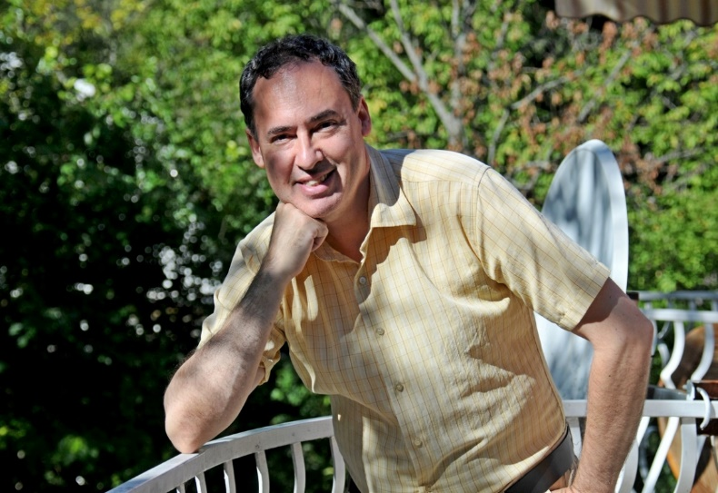

NAME: Balázs Dániel Harcz

DATE/PLACE OF BIRTH: March 11th, 1975, Budapest, Hungary

NATIONALITY: Austrian - Hungarian
MARITAL STATUS: Single

COMPANY: HARCZ & PARTNER, LTD. Translation Company
POSITION: Head linguist, translator, editor, proofreader

ADDRESS: 1121 Budapest, Árnyas út 4. Hungary

TELEPHONE: +36-30-8-500-563 (cell)

E-MAIL: daniel.harcz@gmail.com

FACEBOOK PROFILE: https://www.facebook.com/daniel.b.harcz

PHOTOGRAPHY PAGE: https://www.facebook.com/media/set/?set=a.10207352204141534&type=3

PHILOSOPHY WEBPAGE: https://www.facebook.com/purposeofexistence/

KEY POINTS:

►I speak English at near-native level due to extended stays in the USA and the United Kingdom, and my studies in the Department of English Language and Literature at ELTE University, Budapest.

►Vast experience as a full-time, professional translator and interpreter, entrusted with long-term and high-stakes projects, earning a regular client base.

►I started a translation company, HARCZ & PARTNER Ltd., as a fresh college graduate, which now holds a significant share of the Hungarian translations market, with a thriving growth rate and a distinguished client portfolio, including many repeat clients.

OBJECTIVE: To carry out projects requiring exceptional linguistic expertise, such as:

- Translation projects from English into Hungarian and Hungarian into English.
- Telephone interpretation assignments (between English and Hungarian).
- Creative writing (e.g. speeches, presentations, letters, books, studies).
- Localization and website translation.
- Transcription in English and Hungarian (i.e. retyping of handwritten texts and audios).
- Press watching in Hungarian, English and German.
- Ghostwriting in English and Hungarian.
- Proofreading and editing in English and Hungarian.
- News editing (English, Hungarian).
- Machine translation post-editing (MTPE) in English and Hungarian.
- Literary translation (Hungarian into English).
- Company management, interim company management.
- Any other language-related role that matches my expertise and background.

LANGUAGES:

- Hungarian (native)
- English (near-native fluency in writing and orally)
- German (fluent)

EDUCATION:

1998: Hungarian National Training Center Advanced Tour Guide Certification – English and German

1993-1998: Eötvös Lórand University, Budapest Department of English Language and Literature (DELL)
Master of Arts in English Literary Translation (1998)
Secondary School Teacher’s Certification (1998)
Master of Arts in English - Specialization in English Historical Linguistics (1998)

1989–1993: Apáczai Csere János Grammar School
High School Diploma (1993) English distinction, distinguished track and field competitor
5th Place Achievement Award for English (1993) Hungarian National Academic Competition (OKTV)

SOFTWARE: Windows 10, Adobe Acrobat Professional, Microsoft Office 2017.

CERTIFICATIONS:
- Type-B driving license (obtained in August, 2002).
- Advanced-level, type-C (written + oral) state language examination for English.
- Intermediate-level, type-C (written + oral) state language examination for German.

SKILLS and ATTRIBUTES:
- Highly efficient person.
- Technological fluency.
- Exceptional communication and organizational skills.
- Creative and flexible.
- Single with no children.
- Flourishes under pressure.

ARTICLES PUBLISHED:
- Essay on ethics and empathy in the translation industry (Multilingual, 2007)
- Essay on agency specialisation (Multilingual, 2010)
- Essay on translation agency database management (Multilingual, 2011)
- Essay on risktaking in the translation industry (Multilingual, 2016)
- Altogether 11 articles (average length: 1800 words) published in the American periodical Multilingual between 2006 and 2017, each article discussed matters related to the international translation industry. Some of the articles were of a purely theoretical nature.

PROFESSIONAL BACKGROUND:

I have been involved in professional translation since 1997, working as a full-time translator and editor since graduating in 1998. I have worked on a regular basis for several foreign and Hungarian clients, including translation agencies and direct clients. I have interpreted for the President of Hungary, Mr. Ferenc Mádl, and the Minister of the Interior, Mr. Sándor Pintér. I also provided interpretation services at a Ministry of Health conference held in the Hungarian parliament in 2001.

Over the years, I have translated countless contracts, business letters, agreements, handbooks, patient handouts, certificates, legal documents, meeting minutes, corporate resolutions, newspaper articles, patents, banking documents, three books and various other scripts and texts.

I translated the book Conserving Hungary’s Heritage from Hungarian into English (The Naturalist Publishing House, 1999).

In 2019, I translated the first issue of the 100-page Macroscope Magazine from Hungarian into American English.
In 2021, I translated the second issue of the 100-page Macroscope Magazine from Hungarian into American English.

I also served as the interpreter for ABN Amro Insurance Company for a year and a half. For six years, I have provided the translations of the Court Decisions of HVG ORAC Legal Publishing House from Hungarian into English on a monthly basis, and my translation agency, Harcz & Partner Ltd., has had them translated into German as well.

I have acted as the managing director and project manager for the translation department of Harcz & Partner, Ltd. for twenty-two years and have developed wide-ranging, bona fide management skills as a result.

Invoicing Procedures:
My company works within the bounds of our family-owned business, Harcz & Partner Ltd., and the company works as a subcontractor for its translation agency clients. Thus, clients are invoiced by Harcz & Partner Ltd. Translation Company.

Deadlines:
Tight deadlines do not pose a problem, and do not deduct from performance quality. If a high-quality translation can not be produced within the client’s proposed deadline, I decline the project so as not to sacrifice the quality associated with my company,

International, professional references are available upon request.

I look forward to collaborating with you and/or your firm in the exciting field of precision translations.

Sincerely,

19th, March, 2021, Budapest, Hungary

Balázs Dániel Harcz

